Duolingo and the Interactionist Perspective Model.
Jake Main – EDCI 591 – December 2014
What is Duolingo?

Duolingo is a free online second language-learning program. According to the Duolingo website, it is a “free science-based language education platform selected by Apple as iPhone App of the year in 2013, by Google as Best of the Best for Android in 2013…”

The Pittsburgh based company also claims to have over 38-million users and that using its program for 34 hours is the equivalent of one semester of university level language instruction.

What is the Interactionist Perspective Model?

This is a five step educational model that suggests learners of second languages acquire new language by: first receiving the information, noticing selected words or images, tying those perceived words or images to their existing knowledge base, incorporating it and finally understanding its application thoroughly enough to self-correct errors they may make in interacting with the language.

Detailed steps in the Interactionist Model:
- Input: The material the learner is presented with.
- Apperperception: The process of selecting words and pictures to attain comprehension of the material. It is also known as “Noticing”.
- Comprehension: What can be apperperceived (noticed) without understanding the syntax of the language.
- Intake: The comprehended input that can be integrated into the learner’s linguistic system.
- Integration/Output: The point at which the learner is able to understand the material to a point where they can identify and correct their own errors.
Research has demonstrated that this model could be incorporated into Second Language Acquisition using Multimedia material.

Selecting Words Organizing Words
Verbal Input Verbal/Text Base Verbal Model
Apperperception -> Comprehension -> Intake -> Integration (Learner’s Linguistic System) -> Output
Pictoral Input Visual Image Base Visual Model
Selecting Images Organizing Images

Why choose this 2nd Language program and why this approach?

While I was researching the Interactionist Perspective Model, I kept saying to myself, “Duolingo does that” or “Duolingo follows that principal.” It seemed like a logical fit, since in my previous research, the IP model was chosen specifically for second language acquisition in multimedia environments.

First impressions of Duolingo and its functionality:

I had a group of students who had opted out a French class I had been teaching last year, so that they could study German online instead. They kept talking about how great it was, so I was curious to see which program they were using. At first glance Duolingo looked slick and colourful, and the interface seemed simple enough. I knew however, that without digging my teeth into the functionality of the product, that it was dangerous to judge anything by appearance alone. So I signed up, to see what all the excitement was all about.

The first thing I needed to do was to choose the language I would like to study. The choices were all European languages and they varied from Spanish, to Dutch to Swedish.

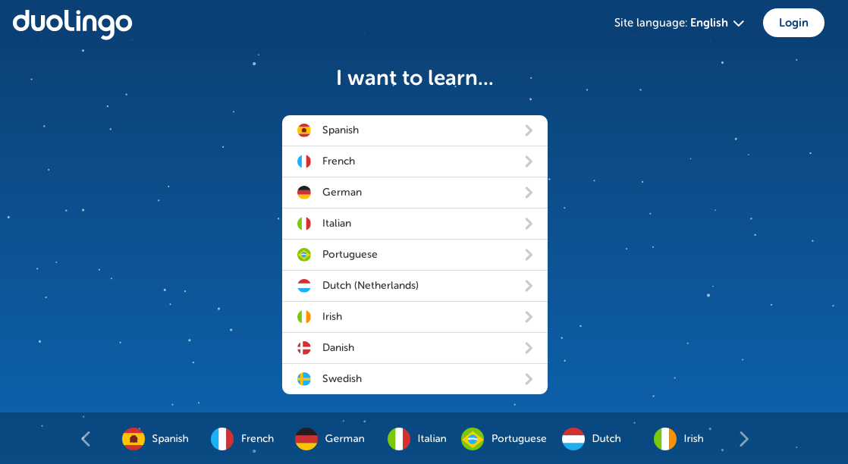

The page also provides users and option to alter the interface language, which in turn gives the learner an opportunity to study English.

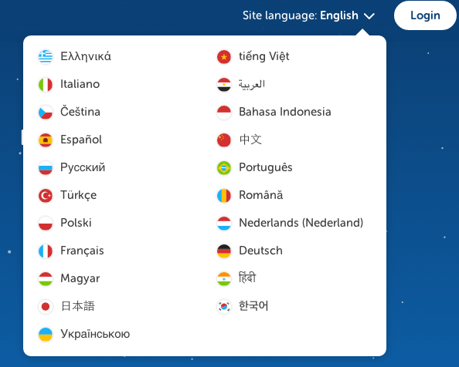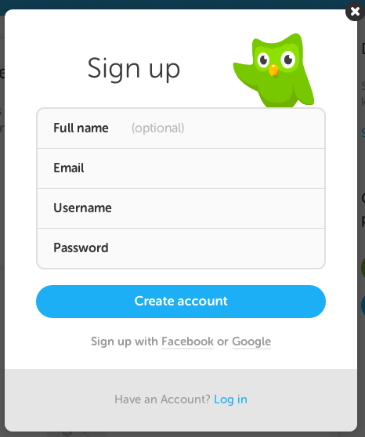

Once the interface and study languages are chosen, the next step was to create a username and password, which much like everything to this point was simple and straightforward.

I was very impressed that the first screen that greets you once you are registered is a screen providing you the option to assess your existing language knowledge. By offering users the opportunity to plug into the program at a level suitable for their skill set, I believe it aids in engaging and challenging the learner, and increases the buy in from the beginning.

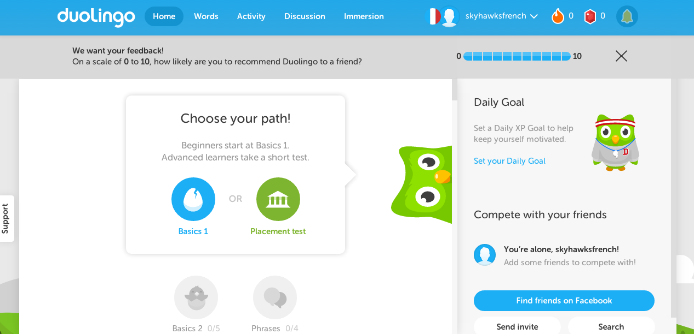

Once into the program, the interface is very colourful, well laid out, logical, intuitive and user friendly.

The designers of the program rely heavily on the use blue and green in their layout. According to research done on people’s emotional responses to color, both blue and green were tops in terms of how they made respondents feel. These colors combined with the primarily white and grey backgrounds are easy on the eyes, which is important given the fact the developers of the program claim that 34 hours of study time with Duolingo is as effective as one term of University Level instruction. That’s a lot of screen time, so keeping the color choices muted and soothing is vital.

How does Duolingo match up with the principals of the Interactionist Perspective Model?

Input:
Duolingo uses a combination of graphic, textual, video and auditory inputs to help engage the learner. Using a stark white background with vibrant primary colours. According to the advice provided for designers of e-learning tools

Developers should use strong and bright colors sparingly or place them over neutral background
tones when designing eLearning materials. This avoids colors become too intense and attracting
the eye in many directions, in which case the technique loses its effectiveness.

The layout of the interface is simple and logical. Text is clean, and not inundated with too much information, therefore reducing the cognitive load. There is also auditory reinforcement provided as the learner takes in the new vocabulary.

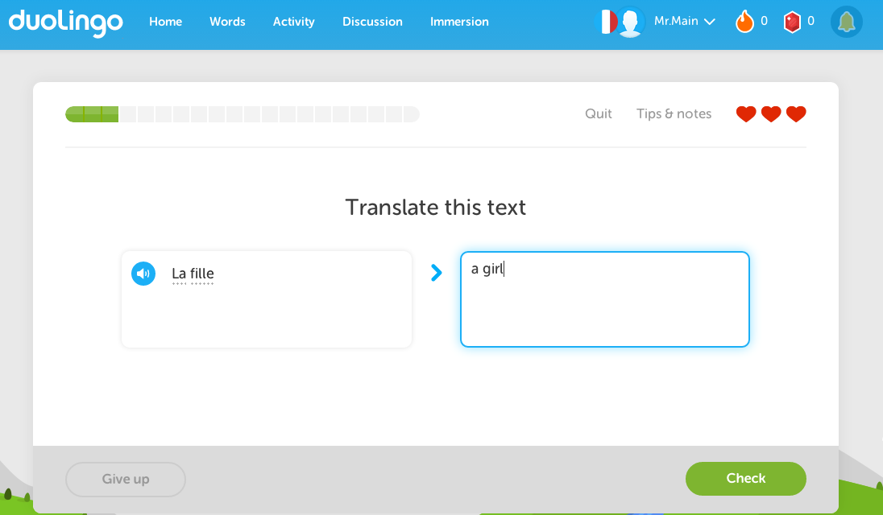
Apperperception:
This stage is about noticing cues and incorporating those images or words into the learning of the new vocabulary. During the Duolingo lessons, especially in the initial stages, more visuals are provided, so that the learner can be successful and build on his/her prior knowledge.

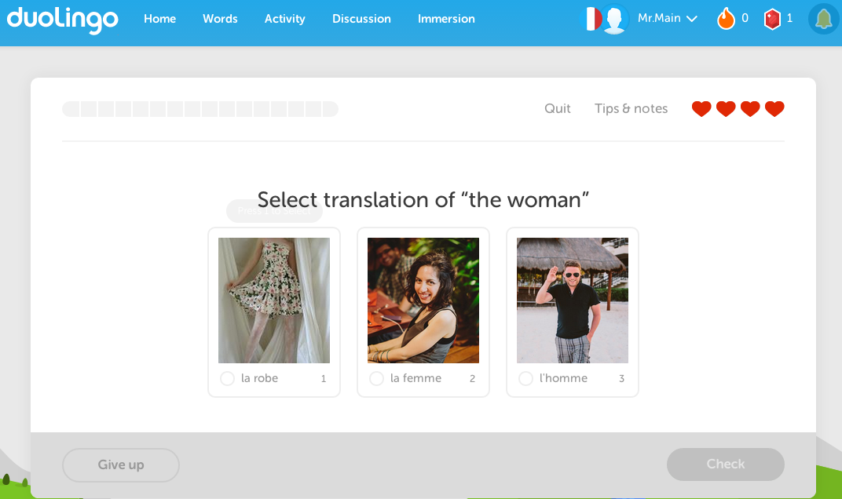
Comprehension:
Duolingo takes a very slow and scaffolded approach to learning a language, building on each of the new skills learned by simply adding a little deeper understanding to the previous lesson, so not to overwhelm the learner. This approach (as seen in the next two screenshots) gives the user a good syntactical foundation to build their new language upon. *In this example the lesson builds on the fact that the learner understands that “une” is an article used before a feminine noun, and by providing the learner examples such as girl and woman, it builds on their prior knowledge that both would fall under the feminine noun classification.*

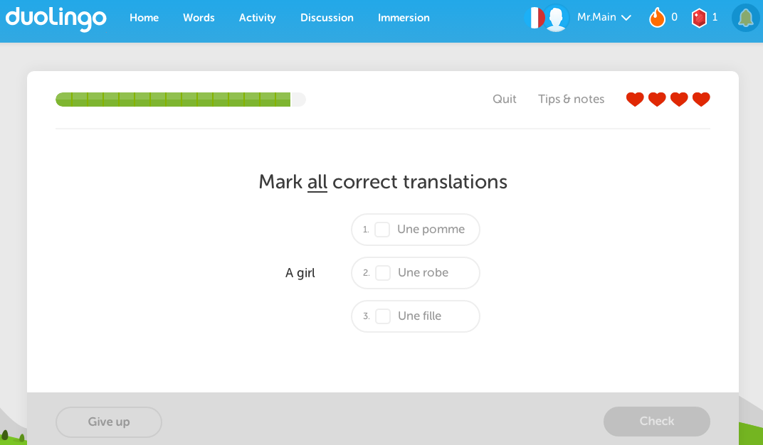
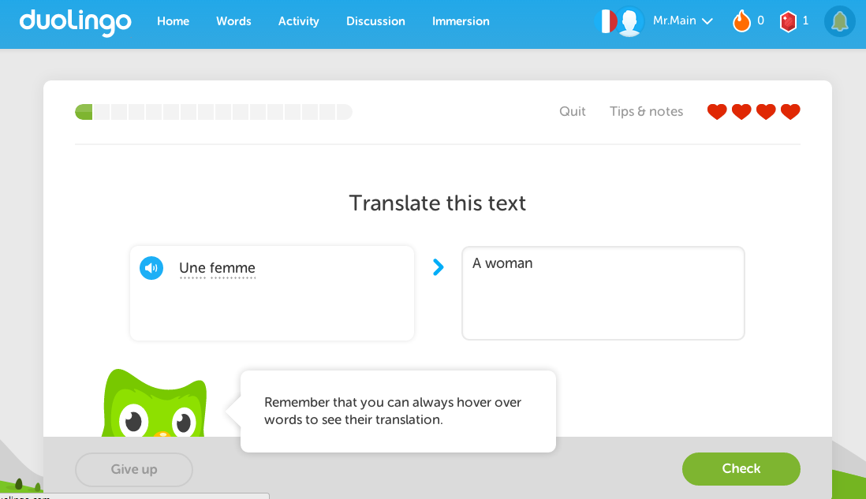

Intake:
The intake is perhaps the most challenging part of this model to assess using of Duolingo, because it is something that is done at the learner level and can only really be assessed by the program in the Integration / Output stage.

Integration/Output:
The program continually monitors the learners’ successes, and requires a certain level of proficiency in order to move onto the next level. On every page, there is an opportunity to see what you did right or wrong, and you can always return to do the lesson again later for greater success.

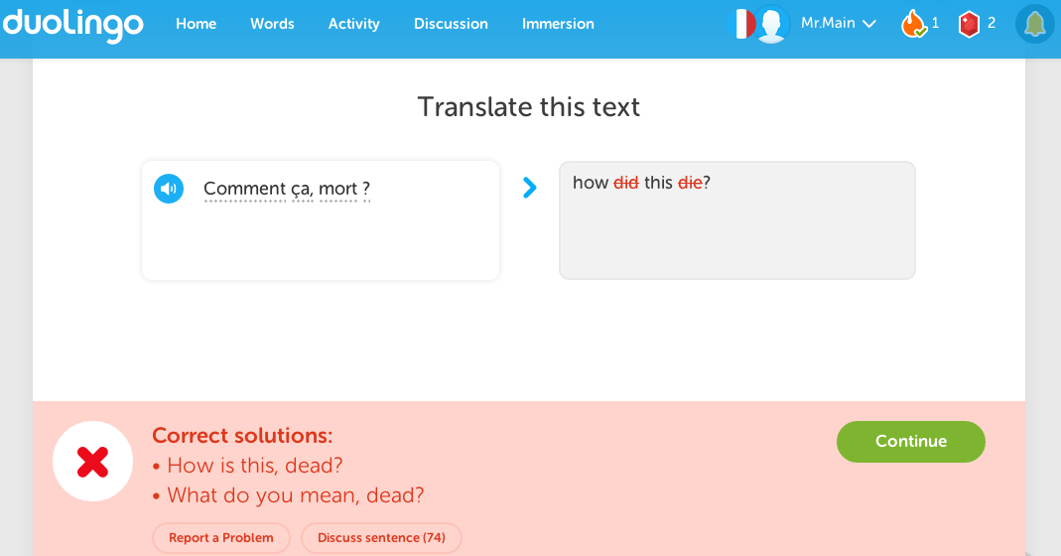

As a way to strengthen the learners’ confidence, Duolingo provides positive feedback, encouragement and possibilities for extending the learning into real life applications.

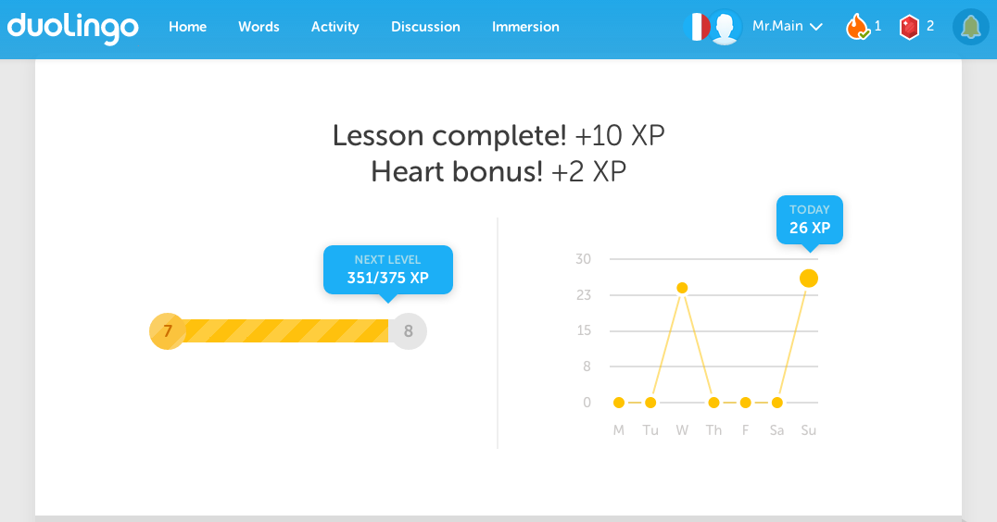

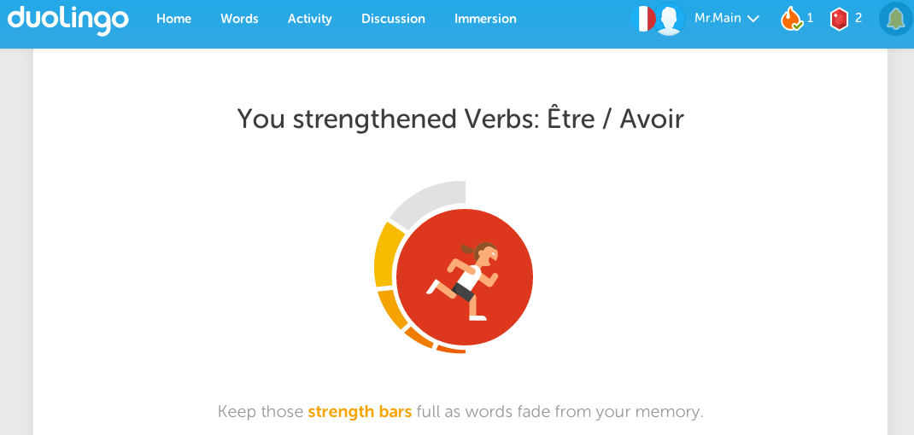

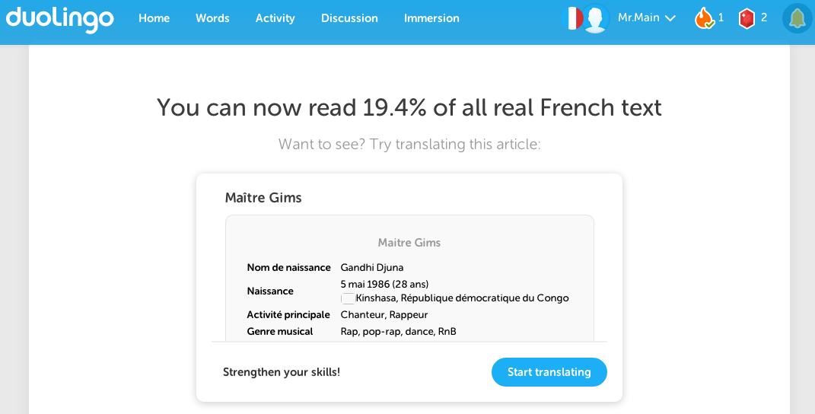

One of the other features that is very helpful for learners is that the program provides an excellent review opportunity on its “words” page. This provides the user an opportunity to review any word they previously learned, review it and strengthen their understanding through using the virtual flashcards option.
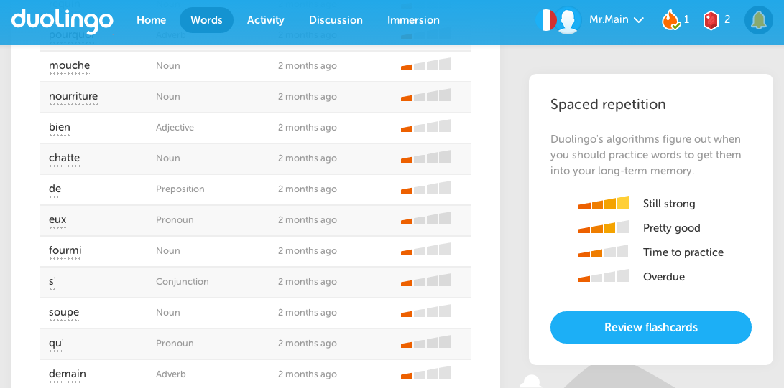

What does the research say about the effectiveness of Duolingo?

The research suggests that Duolingo is as effective as taking a university second language course. The researchers concluded that since one semester of a university course typically takes more than 34 hours of study, therefore the program is equally effective as a first year course. While I don’t dispute the effectiveness of the program, or its ability to augment beginner level Spanish Language test scores, I would like to see more longterm studies with larger sample groups. I would also prefer to see how the results would have differed if all the participants were solely native English speakers. As is indicated in the study, 28.4% of the participants already spoke a second language, which I believe can skew the results. For example, an French or Italian speaking student learning Spanish will already understand many of the basic concepts of the language, because they all share similar grammatical rules and there is a lot similarity between the vocabulary of langue. Also, the study only accounted for the average amount of online time each participant took to achieve his or her level of comprehension over the 8 week study period. 34 hours was the mean, while it took some almost 49 hours of online study to complete the required studies. More research is necessary to see the true effectiveness of the program, and claiming Duolingo is as valuable as a university language course, in my opinion is misleading.

My thoughts on Duolingo?

Because of the user-friendly interface and functionality, its accessibility over a number of different platforms (Mobile, PC, Mac, Tablets) and the fact it is free, Duolingo is an amazing tool for educators and learners alike. It offers learner the choice of where and when they would like to do their learning, it incorporates gaming into learning, and rewards learner by assessing prior knowledge and placing them at a level that is appropriate to keep them challenged and engaged. It is a fantastic resource to help supplement or augment classroom teaching of a second language.

Duolingo Website Homepage Accessible at: https://www.duolingo.com/info
Multimedia learning in second language acquisition. Jones, Linda C. , & Plass, Jan L. (2005) The Cambridge Handbook of Multimedia Learning. New York: Cambridge University Press. 467-488
Emotional Reactions to Color by Kathy Lamancusa Accessible at: http://www.creativelatitude.com/articles/articles_lamacusa_color.html
6 Ways Color Psychology Can Be Used to Design Effective eLearning by Karla Gutierrez Accessible at: http://info.shiftelearning.com/blog/bid/348188/6-Ways-Color-Psychology-Can-Be-Used-to-Design-Effective-eLearning
Duolingo Effectiveness Study. Vesselinov, R. O. U. M. E. N., & Grego, J. (2012). City University of New York, USA. Accessible at: https://www.duolingo.com/effectiveness-study

