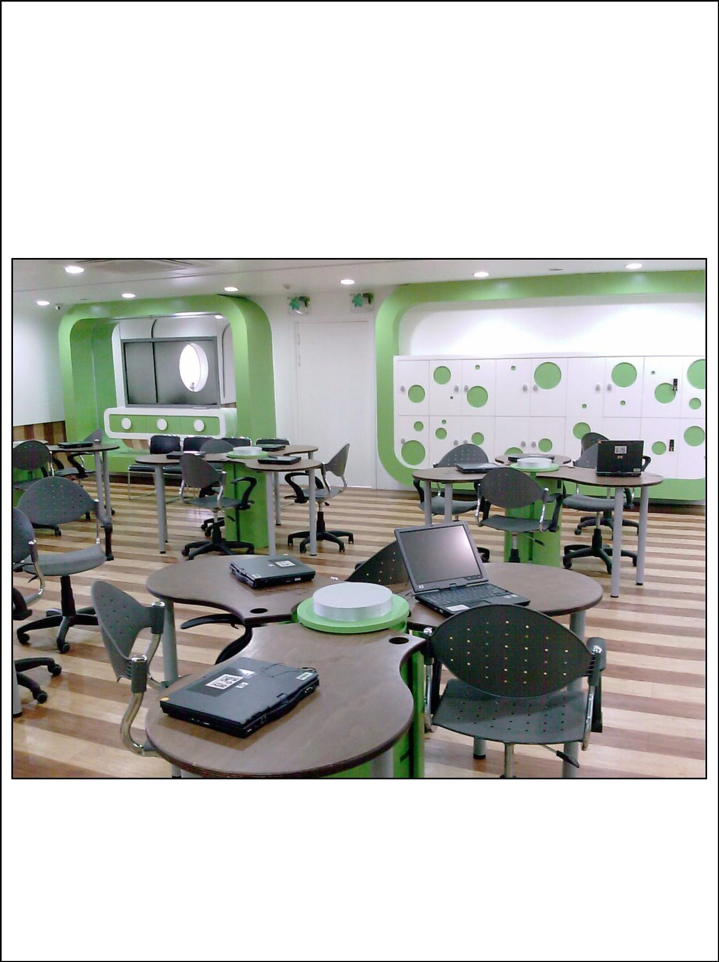
Reimagining

BC Schools

Image courtesy of Korea Education and Research Information Service

HOW TO BRING BC SCHOOLS AND CLASSROOMS

INLINE WITH 21ST CENTURY LEARNING.

Jacob S. Main

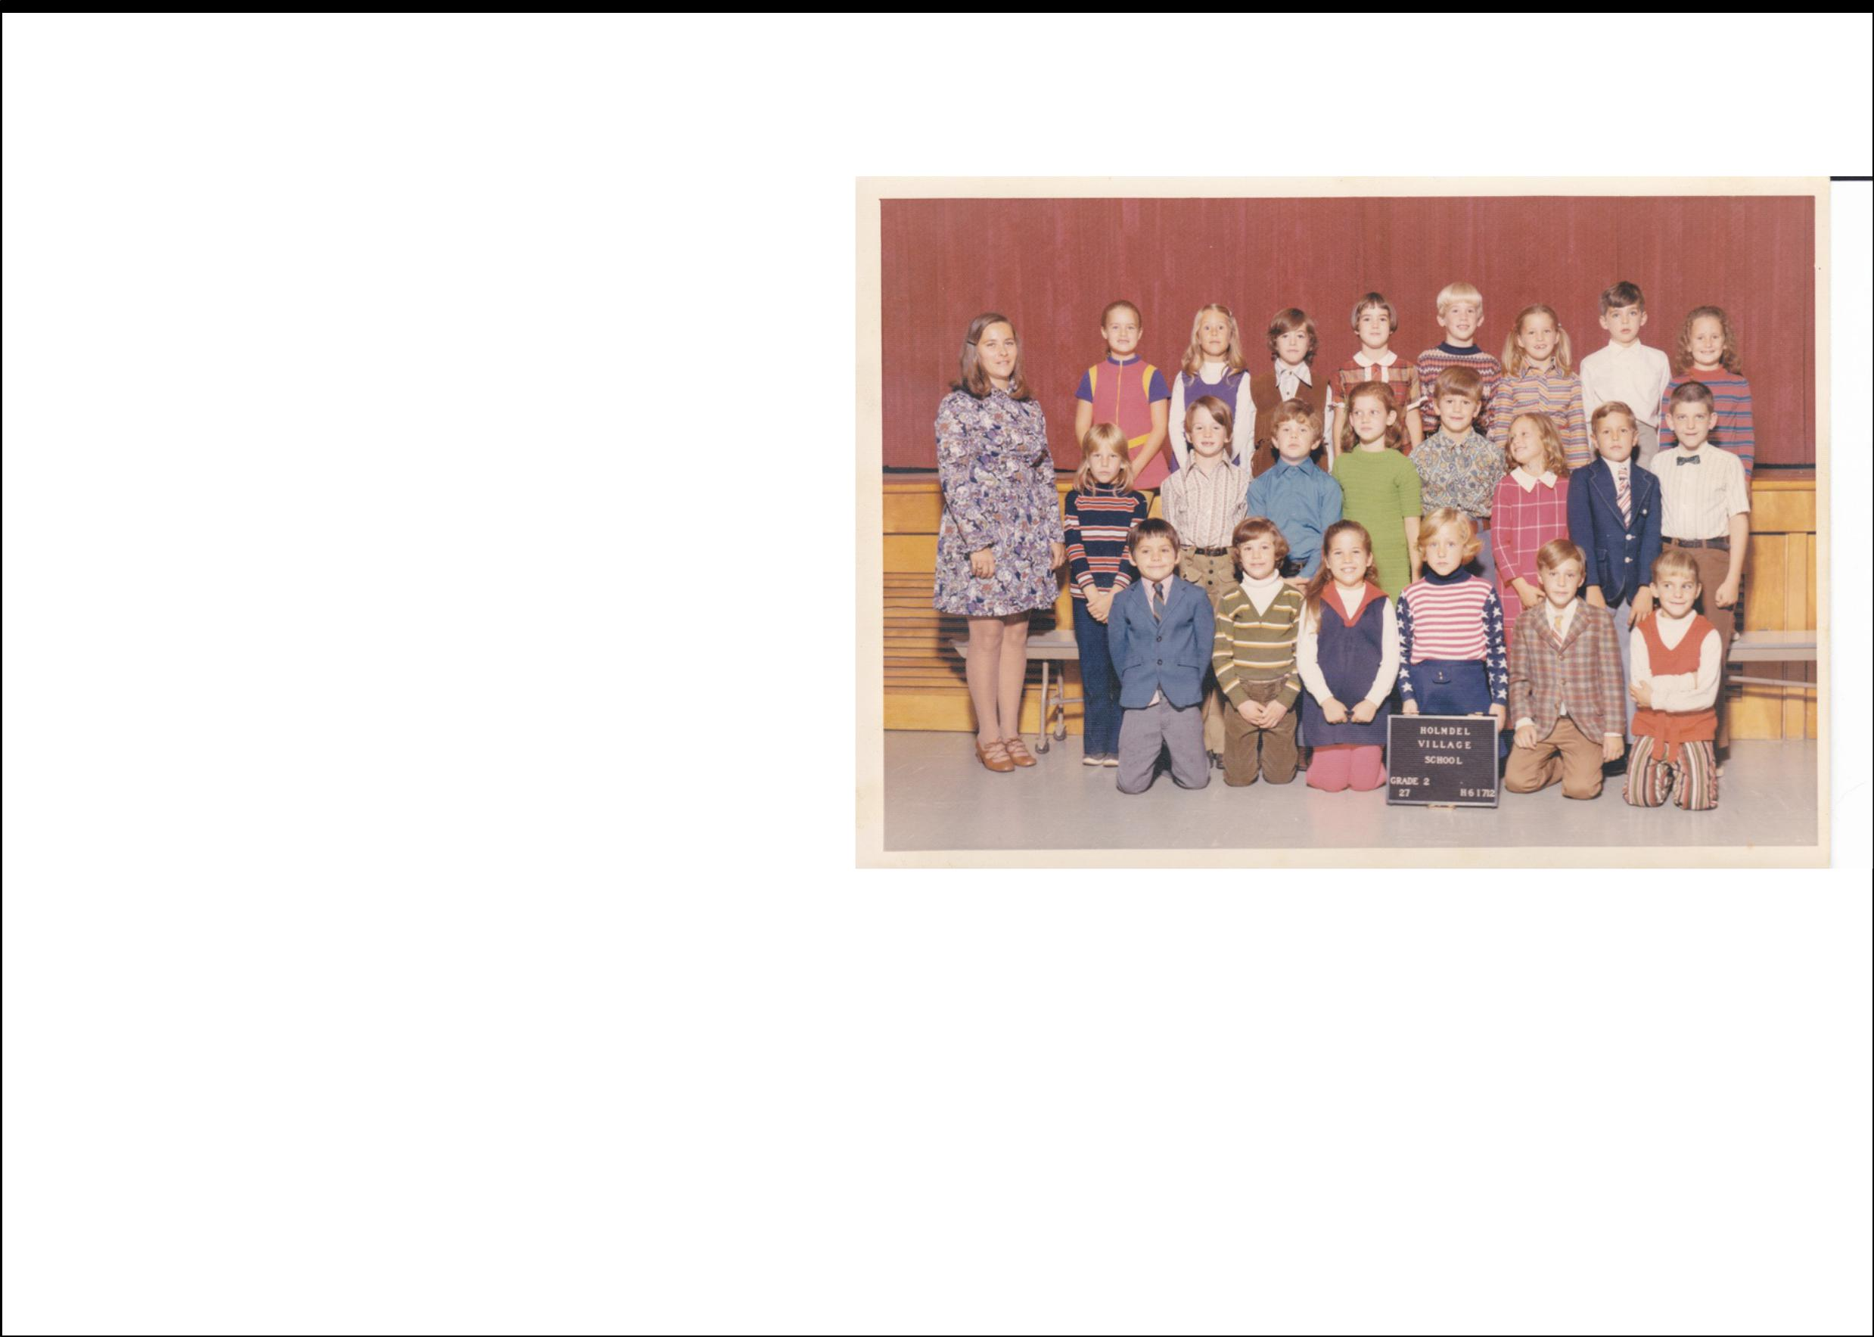
INTRODUCTION REIMAGINING BC SCHOOLS

Time for Change

“Parents fight change because they believe the best thing for their kids is to have an experience like theirs - which they recall through the rose-tinted lens of nostalgia.”

- Newsweek article, September 2014

Peek in the window of almost any classroom across British Columbia, and you’re likely to find a familiar site. Inside you’ll find desks or tables neatly arranged in rows, a teacher’s desk parked near the front class, and white boards, or possibly even chalk boards, intermittently placed around an oﬀ-white, or pale beige room. It’s a common scene, the kind that brings parents back to their days as students. And while those memories may be cherished ones, nostalgia does very little to improve their children’s education.

Image courtesy of Corey Seeman

Grade 2 class photo from Village School, in Holmdel, NJ. 1971 - 72

The problem with the interior spaces in the vast majority of BC schools, is that they are designed to suit the needs of 20th century students. The classrooms may have served the needs of the students’ parents, but most spaces do not lend themselves to helping students learn the skills identified by educational experts as critical, for youth to be successful in the 21st century. If the Province wants graduates who are well prepared to adapt, innovate, create, critically assess, and navigate the future, then we as teachers, administrators, and school district oﬃcials need to reimagine BC schools, so they all can provide BC students with engaging learning environments to hone 21st century skills.

The intention of this e-book is to serve as a resource for educators across our amazing province. It focuses on how changes to the BC curriculum, along with student-centered pedagogical approaches, and improved classrooms design can aid us meet the needs of 21st learning. Hyperlinks to additional web-based resources have been included throughout the text, to help in the reimagining process.

i

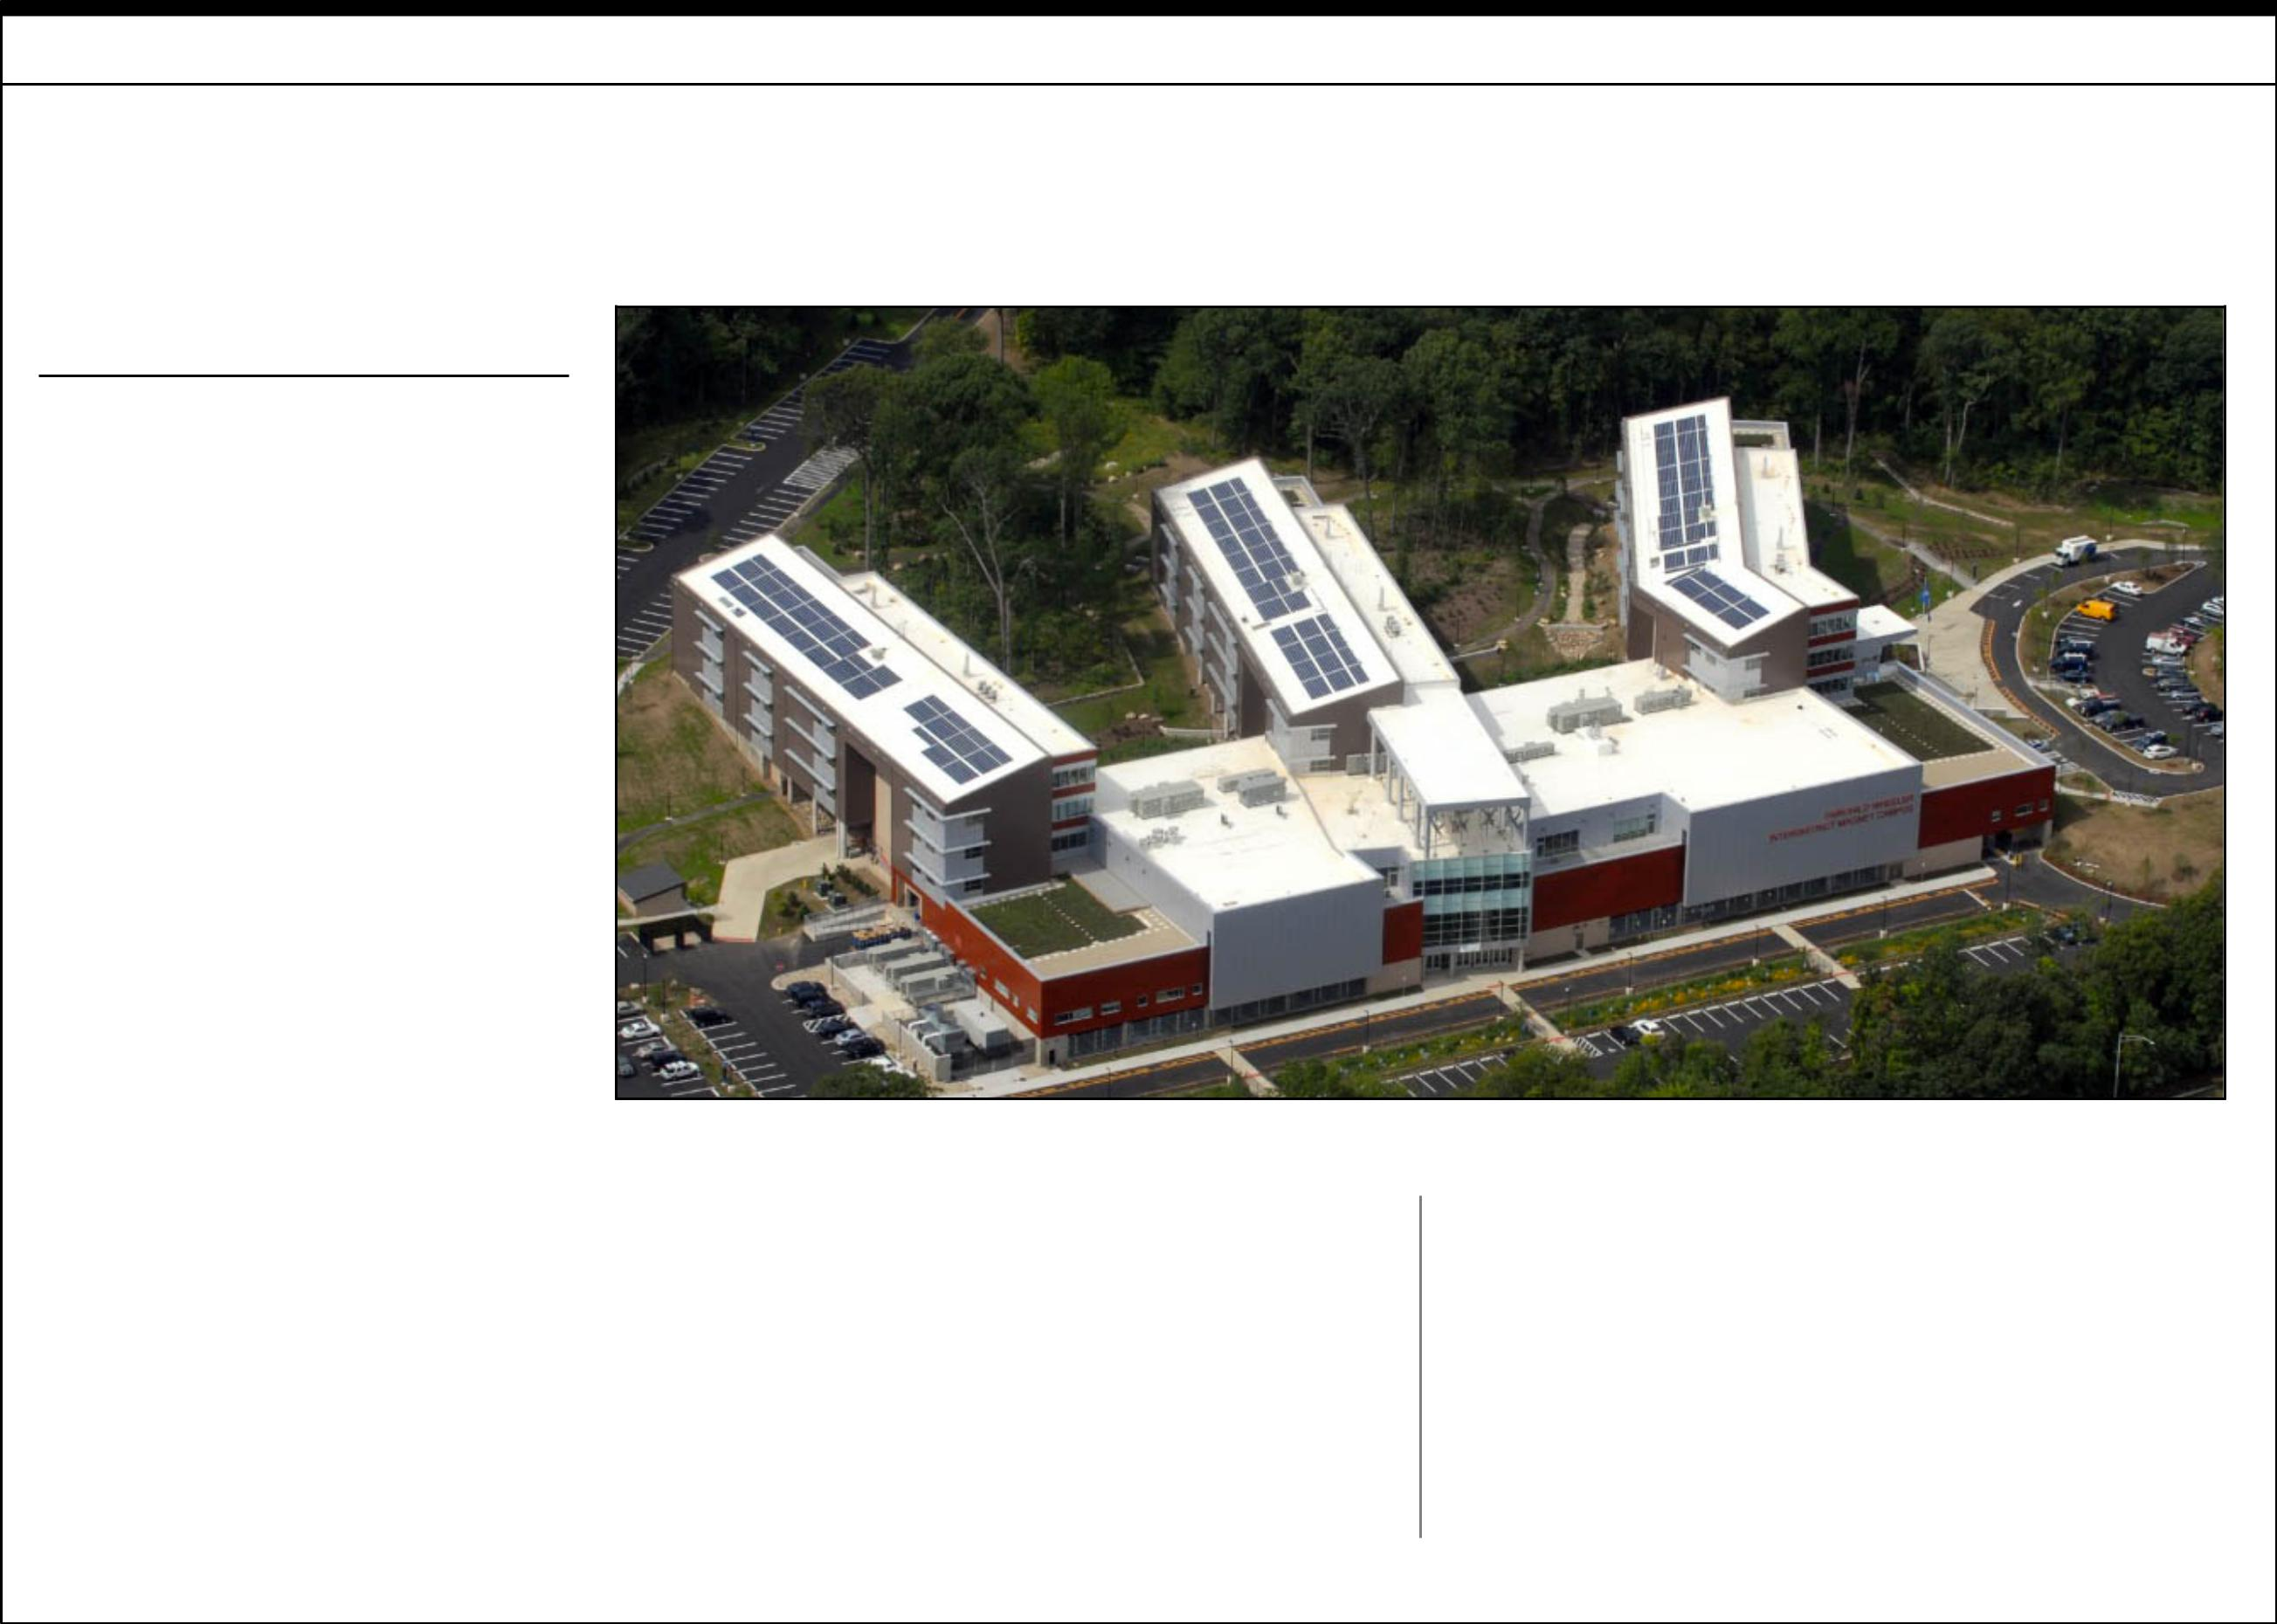
SECTION 1 - RETHINKING AND ADAPTING EXISTING FACILITIES

Rethinking and Adapting Existing Facilities

What can be done?

• Changes need to be made

without relying on additional
funding from the Ministry of
Education. Funding for BC
schools has increased by less
than $400-million dollars since
2006, and only this year as the
funding dollars per student
reached above the $7000 per

student mark.

• Educators need to explore

ways to redesign, rethink, and
remix the schools we already

have.

• Schools need to better utilize

existing spaces to help stretch
education dollars.

Image courtesy of Hearst Connecticut Media

The state of the art Fairchild Wheeler Interdistrict Magnet Campus in Bridgeport, Connecticut cost nearly $130-million to build.

• With the pending launch of

the new provincial curriculum,
teachers, administrators, and
district leaders can be on the
leading edge of change of
education, by reimagining
what schools and classrooms
can be for BC students.

Public education in British Columbia has always been under close scrutiny. Funding totals for BC students only recently crested the $7000 per year allocation threshold, resulting in tough financial decisions for school districts, board trustees, administrators and educators across the province. While student-funding allocations have remained relatively stagnant over the last decade, significant investments in new facilities

have been made to build new schools in growing communities. This means however, that cities and towns with stable or declining populations are less likely to get new schools. With a new school costing upwards twenty millions of dollars, it is increasingly important to reimagine how we use existing facilities across the province.

2

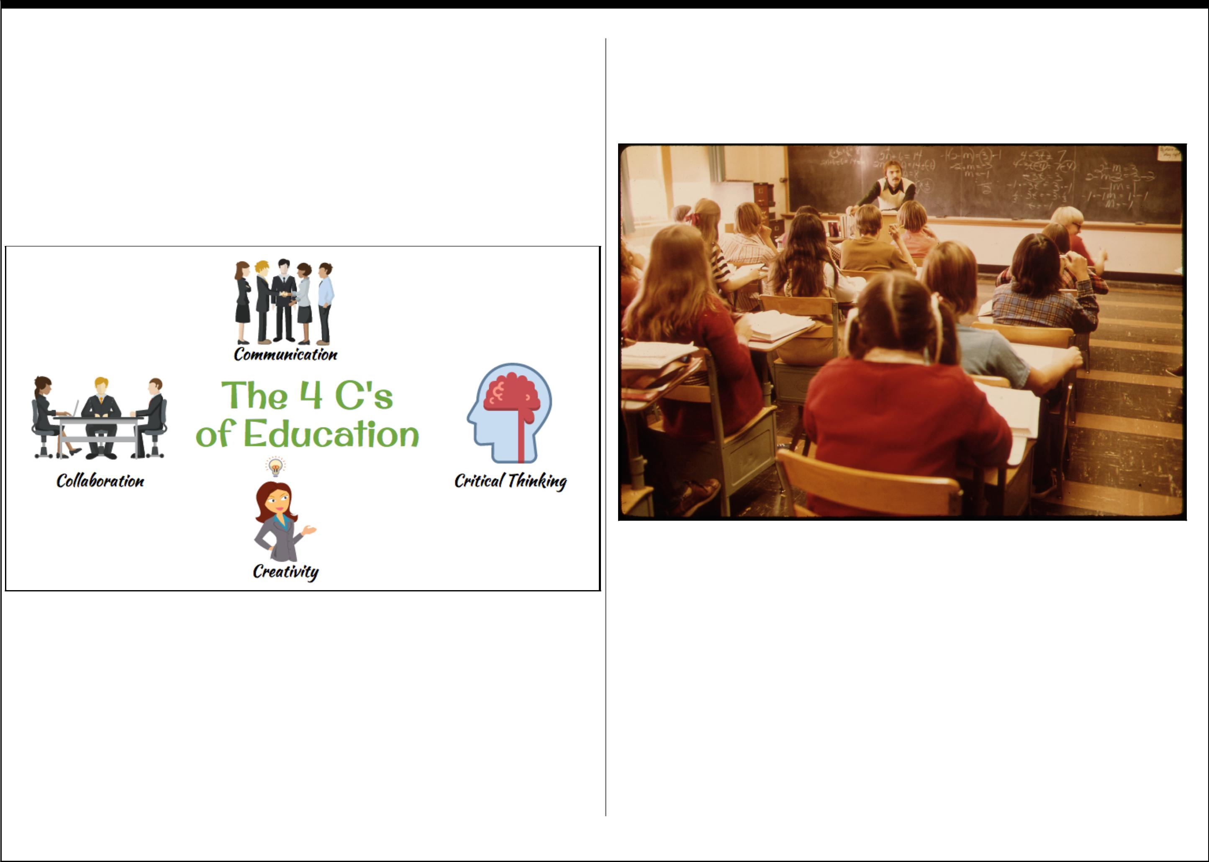
How do we Reimagine Existing Spaces?

While the idea of transforming physical spaces of the classroom and school, is not a new one, the reality is that in order to prepare today’s students for tomorrow’s challenges, they need, and deserve, to have environments that foster the cornerstone attributes of 21st century learning: Communication, Critical Thinking, Creativity and Collaboration.

In the 1960’s and 70’s a number of schools across the continent adopted an educational and architectural approach called “Open Concept Schools”. The concept was based in the idea of the old single room school house, where the teachers taught all subjects to a class of students of diﬀerent ages and abilities. The “open classrooms” were large open spaces where a team of teachers would instruct a multi-aged, multi-leveled group of students at the same time. Afer some initial success, the idea was scrapped in
favor of a more traditional approach, and nearly all of the “open schools” were portioned up with walls, room dividers or bookcases, and students reassumed the familiar configuration of desks in rows, and teachers at the front of an enclosed classroom.

Photograph courtesy of David Stroble

A typical classroom layout for students in a non-open concept classroom in the 1970’s. Teacher in front, a blackboard and desks in rows.

Why go back to a Failed Model?

Perhaps calling the “Open Concept Classrooms” experiment a failure is a bit harsh. Maybe the idea was ahead of its time? Maybe there wasn’t the necessary willingness to make it work, or perhaps the technology of the day, simply made it an ineﬀective model for most educators? In any case, times have changed, and the needs of students are no longer best served in static or confined spaces. It may be time to re-open the classroom setting, giving the room

3

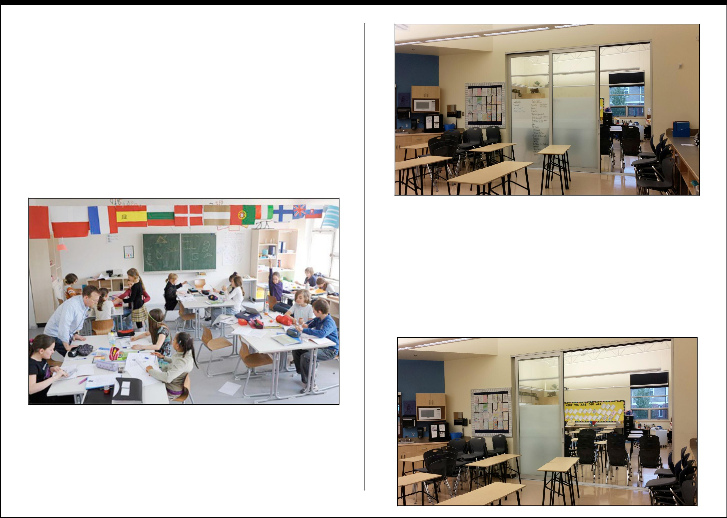
more flexibility and flow, and to place more focus on the learning of the students, and not solely the convenience of the teacher.

Education and design experts suggest that new schools and classrooms should be adaptable, open, and washed in natural light. Furnishing should suit a variety of learning styles, and classroom configurations should be easily adaptable to the needs of the activity or lesson.

Seating arrangements should be suited to the learners needs and not solely on that of the educator. Shapes, colors and sizes of furniture should be functional, flexible and help foster creativity.

Photo courtesy of Jens Rötzsch

A student-centered classroom setting at the Berlin Metropolitan School.

With these considerations in place, a number of newer schools that have been built around the Lower Mainland of British Columbia seem to be taking this more adaptive and open approach to the design of their buildings.

Yorkson Creek Middle School in Langley, BC utilizes large sliding glass doors to separate pairs of classrooms. The doors not only help create a sound barrier between the two rooms, but because of the translucence, they allow the natural light to flow through and increase the overall light quality in each classroom. With the sliding doors open, the environment lends itself to more collaboration between classes, and creates a larger, more fluid and flexible work environments for students and teachers alike.

4

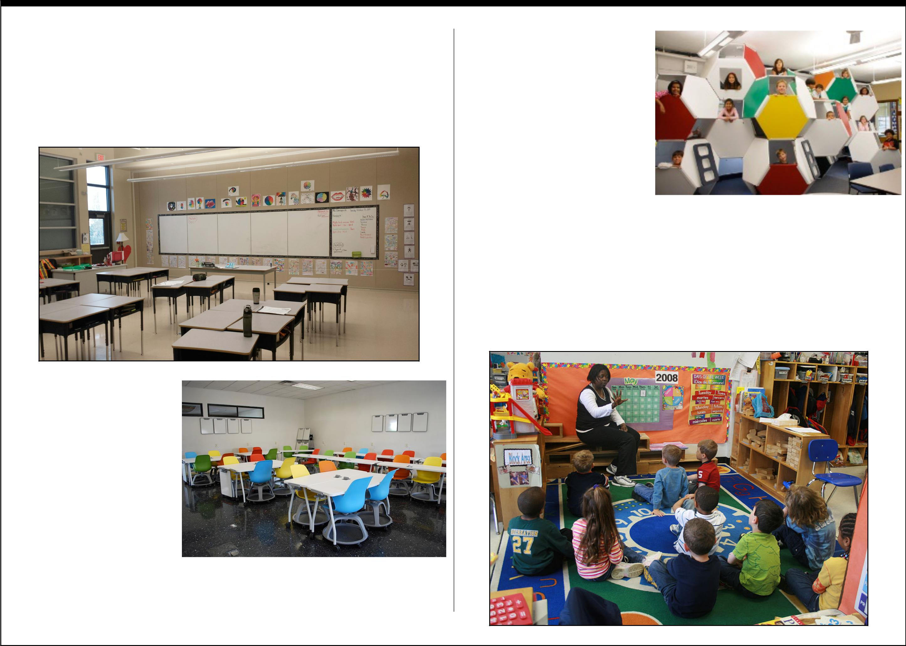
At Katzie Elementary in Surrey, BC, a diﬀerent approach has been taken as two large classrooms have been adjoined by an accordion-style solid sliding wall. While the closed accordion wall doesn’t provide any additional light into the space, it does provide a much more open working environment than the smaller glass sliders used at Yorkson Creek Middle School.

In both these examples,
the classroom |  | colours
were kept neutral, and
small rectangular desks
were used as adaptable
student work |  | spaces.
Some | other | schools
have | taken | a more
colourful and |  | radical
approach. |  |  | Image courtesy of Leigh Thelmadatter

Take for example the rainbow-col0ured rolling chairs and desks at the Monterrey Institute of Technology and Higher Learning in Mexico City.

Taking an equally colourful,
but more unconventional
approach, |  | educators |  |  | at
Avery Coonley |  |  | School |  | in
Illinois, developed a radical
solution | to | individualized
student | learning. |  |  | ACS’s
“interconnected |  |  | learning
spaces” | feature |  | a | semi- |  | Image courtesy of Avery Coonley School
private pod |  | with a |  | fold-

down seat, a reading light, and a bookshelf. While certainly not the most collaborative work environment, it definitely pushes the envelope of classroom design.

What about the impact of Classroom Colour and Furnishings?

Image courtesy of woodleywonderworks

5

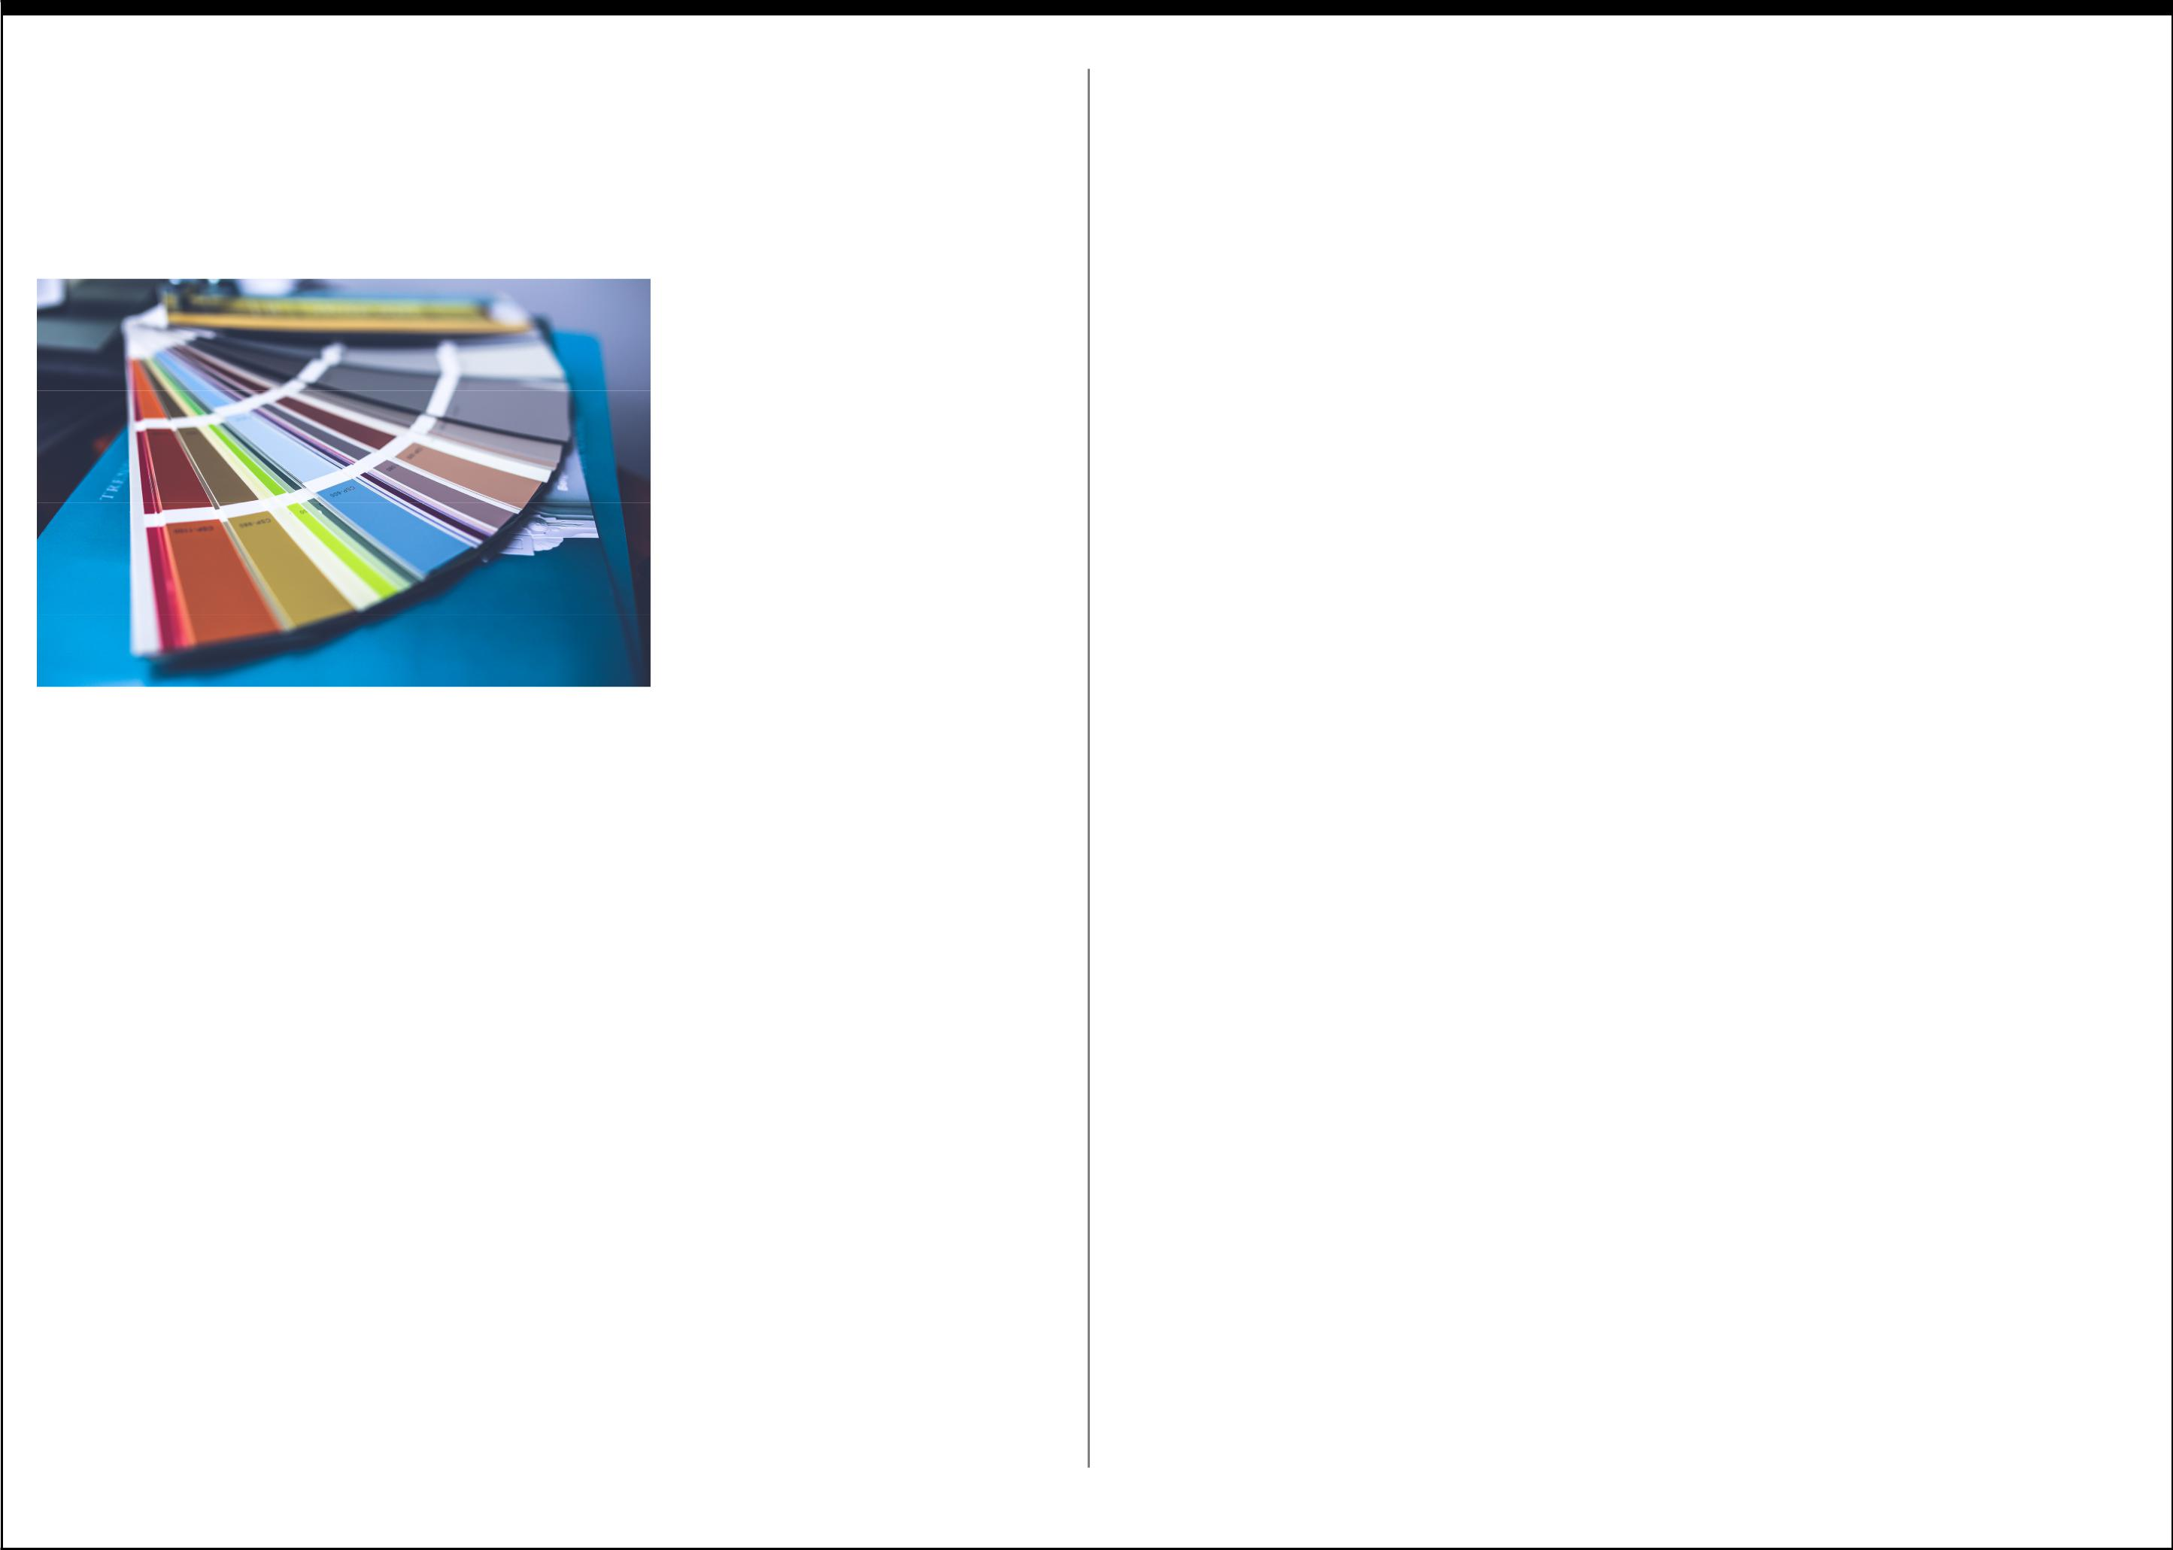
Take a look inside almost any primary classroom, and you will likely see walls covered in brightly coloured posters, images, and charts. Yet look inside an intermediate or high school classroom, and the colours seem to disappear.

 | Randall Fielding, an
 | expert in educational
 | architecture suggests
 | that there are simple
 | truths around the use of
 | colour in schools, and
 | that covering classroom
 | walls in beige, gray and
Courtesy of www.pexels.com | oﬀ-white paint, is not
 | one of them.

Randall Fielding’s Expert Colour Tips:

1) Primary Colours are not always best.

Children tend to prefer colors of nature and human skin tones, and primary colors can be harsh, and are best used sparingly.

2) Don’t get caught up in color stereotypes.

Research that indicates red incites aggression, and that green is relaxing is overly simplistic and outdated. Diﬀerent colours used thoughtfully, can all be eﬀective in learning environments.

3) Don’t get stuck in Neutrals.

There is a long standing common myth that neutral colours keep the focus on the teacher and not the architectural elements of a room. Research into colours indicates that learning “benefits from a carefully applied stimulus-rich environment, not from a palette dominated by gray, beige, white, or oﬀ-white.”

Putting it all Together:

Classroom Design and Layout

In the course of this first section, a number of points around classroom design have been suggested, and they include:

- Classroom spaces should be flexible.

- Classrooms need to provide enough room for easy movement.

- Classrooms should feature a lot of natural light.

- Classrooms should be focused on student learning.

- Classrooms should oﬀer both individual and collaborative spaces.

- Classrooms should have adaptable furnishings.

- Classroom colours should be thoughtfully chosen.

What has yet to be addressed, is how do teachers get started with their redesign?

With help from Edutopia, designers from the Stanford D School, and members of the Third Teacher+ design team took these design tips and put them into practice at Roosevelt Middle School in San Francisco.

Here are the YouTube links to each of the Remake your Classroom videos:

Remake your Classroom - Part One

Remake your Classroom - Part Two

Remake your Classroom - Part Three

6

Here is a list of recommendations for how to improve classroom design and functionality, based on the advice given in the 3 part video series.

All finalized classroom designs should:

- Match teaching and learning goals.

- Improve teacher/student mobility, overall flow and utilization of existing space.

- Incorporates the students’ preferences and suggestions.

- Focus on sustainable design by using recycled, repurposed and reclaimed materials.

- Have a realistic, but manageable budget. To keep costs in check, and to realize a truly collaborative design, the work should involve educators, students, community support and volunteers.

Based on the advice given, here are the key takeaways from the three part video series and the design experts’ advice:

Planning Portion of the Design:

- Consider the educators’ needs and preferences when creating a teaching zone.

- Consider how layout can improve classroom flow. Collaborative learning environments require adaptable rooms that are easy to move around.
- Thoughtfully plan diﬀerent styles of collaborative work spaces.
- Remember to increase space within the classroom by providing adequate storage.

- Classroom furnishings should be sturdy, adaptable and varied.

Execution of the Design:

- Declutter & Clean. Get rid of things you no longer need, and clean all surfaces.

- Reconfigure. Consult and brainstorm diﬀerent configuration for classroom furnishings with all user groups (especially the students).

- Repurpose & Reuse. To help minimize cost and the impact on the environment, consider how existing furniture can be refreshed, reused or repurposed.

- Share the Spotlight. Don’t be afraid to get the school community and volunteers involved.

Revealing and Reveling in the Design:

- Enjoy and chronicle the process as you go, and don’t be afraid to adapt plans if something better is proposed.

- Invite the community to celebrate in the results.

- Reflect on learning. What was learned, which skills were honed as part of the design and remake process.

- Always consider ways to improve and adapt the space. Even the greatest designs can be improved upon.

7

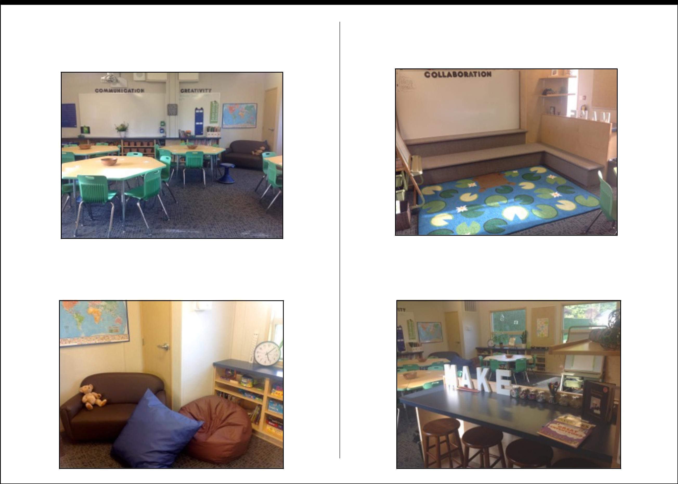
What does a Reimagined BC Classroom look like?

Image Cour-

Image Courtesy of Alison Galloway

The classroom of BC Educator Alison Galloway is a perfect example of how to eﬀectively use earth tones, and not primary colours, to oﬀset her oﬀ-white walls, creating an open and inviting room.

Image Courtesy of Alison Galloway
Galloway’s classroom furnishings are functional and adaptable, and the help bring much needed colour, texture and variety to an otherwise neutrally coloured room.

Image Courtesy of Alison Galloway

The furnishings and layout provides a number of diﬀerent learning zones, and seating options for the students to collaborate, make and create in.

Image Courtesy of Alison Galloway

8

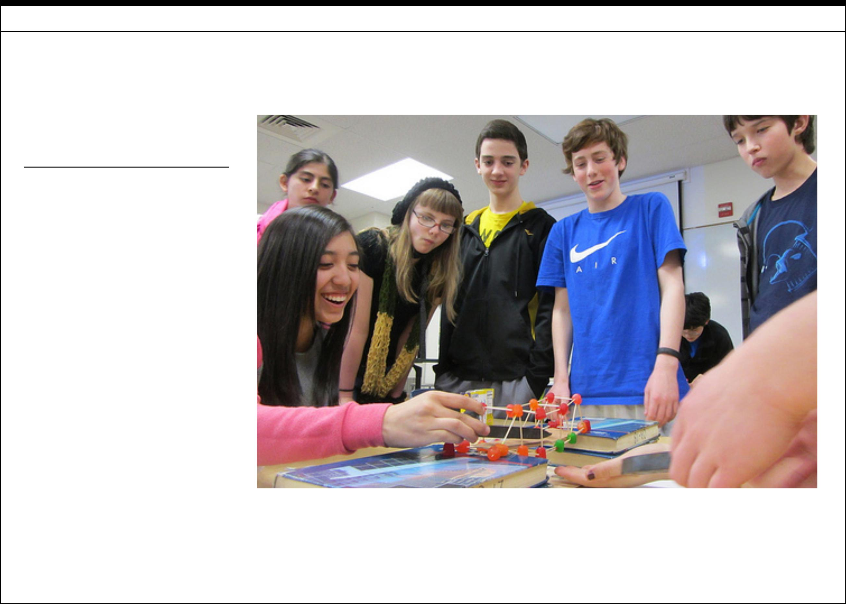
SECTION 2 - RETHINKING CLASSROOM APPROACHES

Rethinking Classroom Approaches

Putting the Focus

on the Learner

- Requires students to be active learners, and take more responsibility for their education.

- Requires teachers to be comfortable in turning the wheel over to the student to drive their learning. Become more of a facilitator, mentor and advisor.

- Important to learn about students’ prior knowledge, and correct any misconceptions.

- Classroom time needs to be purposeful, relevant and engaging.

- Time needs to be given for synthesis & reflection.

- New projects or problems should be introduced with “mini-lectures” to help frame, explain and clarify expectations.

- Works best when there is more time provided for student work and fewer class changes.

 |  |  | Image courtesy of Oregon Department of Transportation
 | Student learning is not |  | While the first section of the e-book addresses
 |  |  | the need to remake the classroom, section two
something done to them, it
 |  |  | tackles how educators can best use the time they
is something done by them. |  |  | have with their students to guide them in the
 |  |  | leaning process.

9

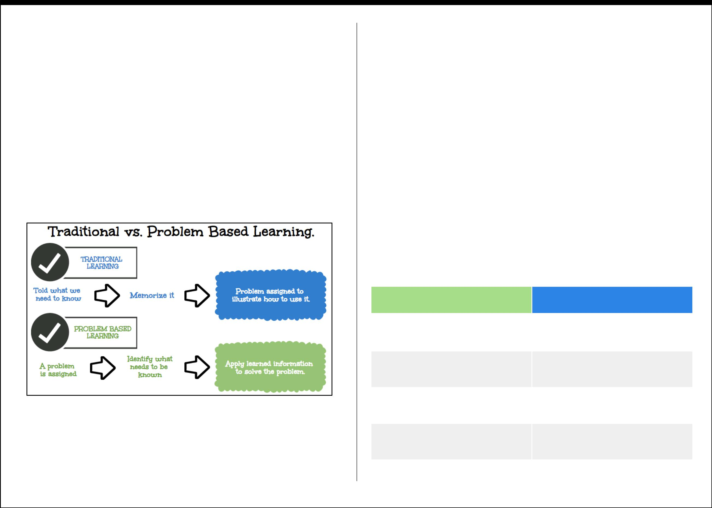
What Needs to Change?

Students need to take a greater role in their learning experience. Traditional learning approaches viewed students as “empty vessels” needing to be filled. Teachers were viewed as the fillers of those vessels, by passing along knowledge to the students. In turn, students’ were expected to memorize the information, and the proof of “learning” came by reiterating what they retained on a test. In this traditional approach, the student is a passive recipient of knowledge, and learning is limited to the confines of the lesson or assignment. This traditional approach does little to develop the critical thinking or creative thinking skills necessary to take a diﬀerent look at real world problems.

Infographic based on graphic from PBL Learning at Small Middle School

If the expectations of students are to follow, restate information taught, and not question authority, then the traditional approach remains an eﬀective model. If schools hope to cultivate creative, innovative and imaginative thinkers, then a diﬀerent approach needs to be taken. The approach necessary is a well-planned, student-centered PBL approach to classroom learning.
What exactly is PBL?

There is some well deserved confusion around exactly what P.B.L stands for. Is it Project Based Learning or is it Problem Based Learning? The short answer is...yes. PBL is interchangeable between to two learning approaches, which are very similar, but not exactly the same.

The following comparisons stem from an excellent article by John Larmer, the Editor in Chief at the Buck Institute for Education.

Similarities between Project and Problem Based Learning:

- Focus on an open-ended question or task.

- Provide authentic applications of content and skills.

- Build on 21st Century Skills.

- Emphasize student independence and inquiry.

- Are longer and more multifaceted than traditional assignments.

PROJECT BASED | PROBLEM BASED
Ofen multi-subject | More ofen single subject, but
 | can be multi-subject
Can take weeks or months to | Tend to be shorter, but can be
complete | lengthy
Follows general, variously- | Follows more traditionally
named steps | prescribed steps
Includes the creation of a | Doesn’t always require a product,
product or performance | perhaps just a suggestion
Uses real-world, authentic tasks, | Ofen uses fictitious scenarios as
settings or scenarios | “ill-structured problems”

10

How can PBL be integrated into Classroom Practices?

Adopting a PBL approach requires a lot of planning on the part of the teacher, but if creating a student-centered, inquiry-based learning environment is paramount, then it is worth the additional time and eﬀort.

Advantages of a PBL classroom:

- More active, hands-on learning and collaboration between students.

- Projects or Problems are ofen based on authentic challenges.

- Work is student driven and inquiry based.

- Teaches the students practical life long skills such as problem solving, critical thinking, peer interaction, creativity and patience.

- It is well suited for cross-curricular or multi-grade level learning.

Challenges of a PBL classroom:

- Requires the educator to do a lot of pre-planning, trouble-shooting and experimentation prior to introducing the problem or project.

- PBL needs adaptable work environments and flexible teaching timetables.
- PBL requires the teacher to relinquish their role as provider of knowledge, and embrace the role of educational facilitator.

- Because PBL is frequently student-driven, it can pose diﬃculty for unmotivated students, students with learning challenges, and those who are new language learners.

How does PBL integrate with the new BC Curriculum?

Before setting out to overhaul and update the current provincial curriculum, the Ministry of Education enlisted help from educational experts from across BC to help carve out and justify a new direction for the curriculum. Afer years of consultation and meetings with representatives from the Ministry of Education, prin-cipals, superintendents, school staﬀ members, teachers, parents, school trustees and students from across the province, it was agreed that BC needed a more flexible curriculum that prescribed less, and enabled teachers and students more.

The following three graphics were captured from the BC Ministry of Education’s new curriculum webpage, and demonstrate and explain the importance of the new Cross-Curricular Competencies. The competencies place increased importance on educating well-rounded communicators and thinkers, who are empathetic and socially responsible in their interactions with others.

Graphics courtesy of the BC Ministry of Education

11

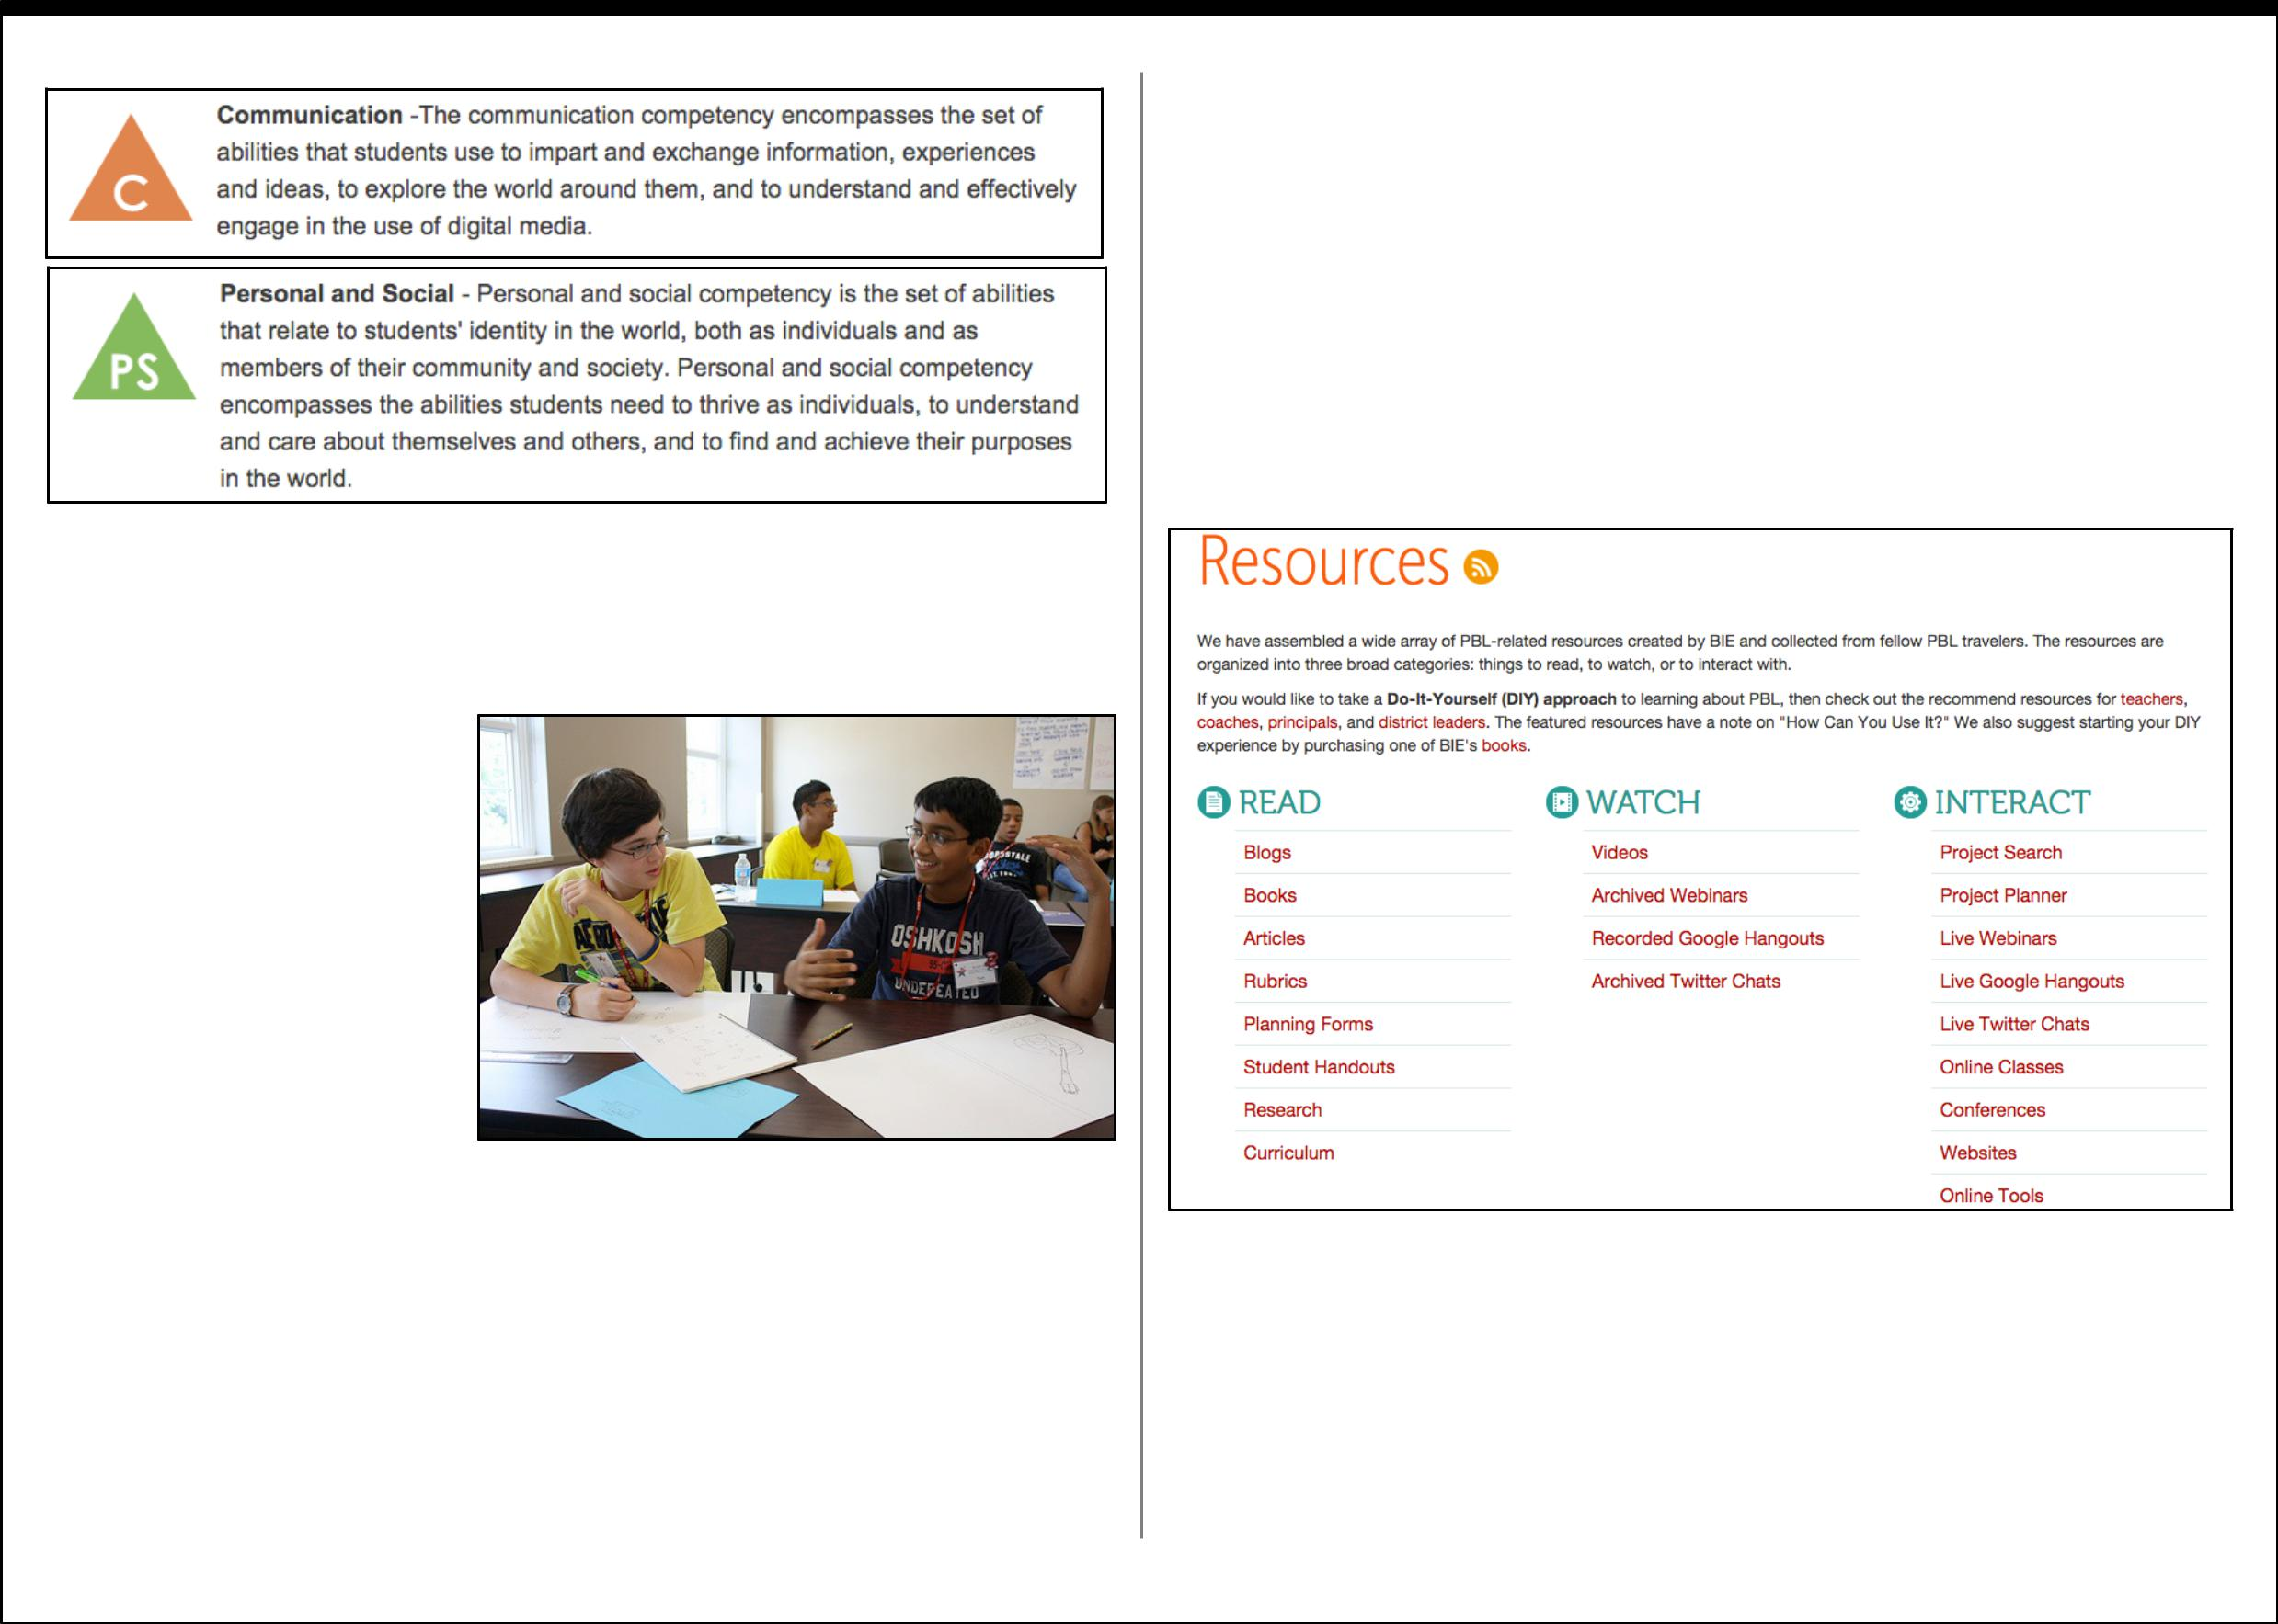

With the new focus on a more flexible and adaptable curriculum in place, educational experts from across BC came up with a set of Cross-Curricular Competencies to help frame the new curriculum.

- Communication

- Critical Thinking

- Creative Thinking and Innovation

- Personal Responsibility and Well-being

• Social Responsibility | Image courtesy of gifedstudieswku

What is most encouraging about the new BC curriculum, is that it should empower teachers to customize their classes to their students’ needs, and not solely to those of the curriculum. The changes provide a more flexible platform from which to work and learn, for both the students and educators alike.
Sounds good, but where do I begin?

As previously mentioned, adopting a PBL approach takes a lot of forethought and planning to implement eﬀectively. Fortunately there are a lot of fantastic free resources to help you get started on the web.

Here are some of the better ones:

Buck Institute for Education Resources Page

This webpage has the most access to diﬀerent forms of PBL links and resources.

The Buck Institute for Education is a non-profit organization with a focus on helping teachers, schools and school districts establish PBL learning environments for their students, in all subject areas and grade levels.

12

Edutopia Project Based Learning Page

Edutopia PBL Planning Page

Both webpages provides access to articles, blogs, videos and other web-based resources.
Edutopia is part of a George Lucas Educational Foundation, and it is an educational website created to be an online community for educators, students and parents. Edutopia’s goal is to increase knowledge of collaborative practices for K - 12 education, in hopes of fostering more innovative, and creative leaders and learners.
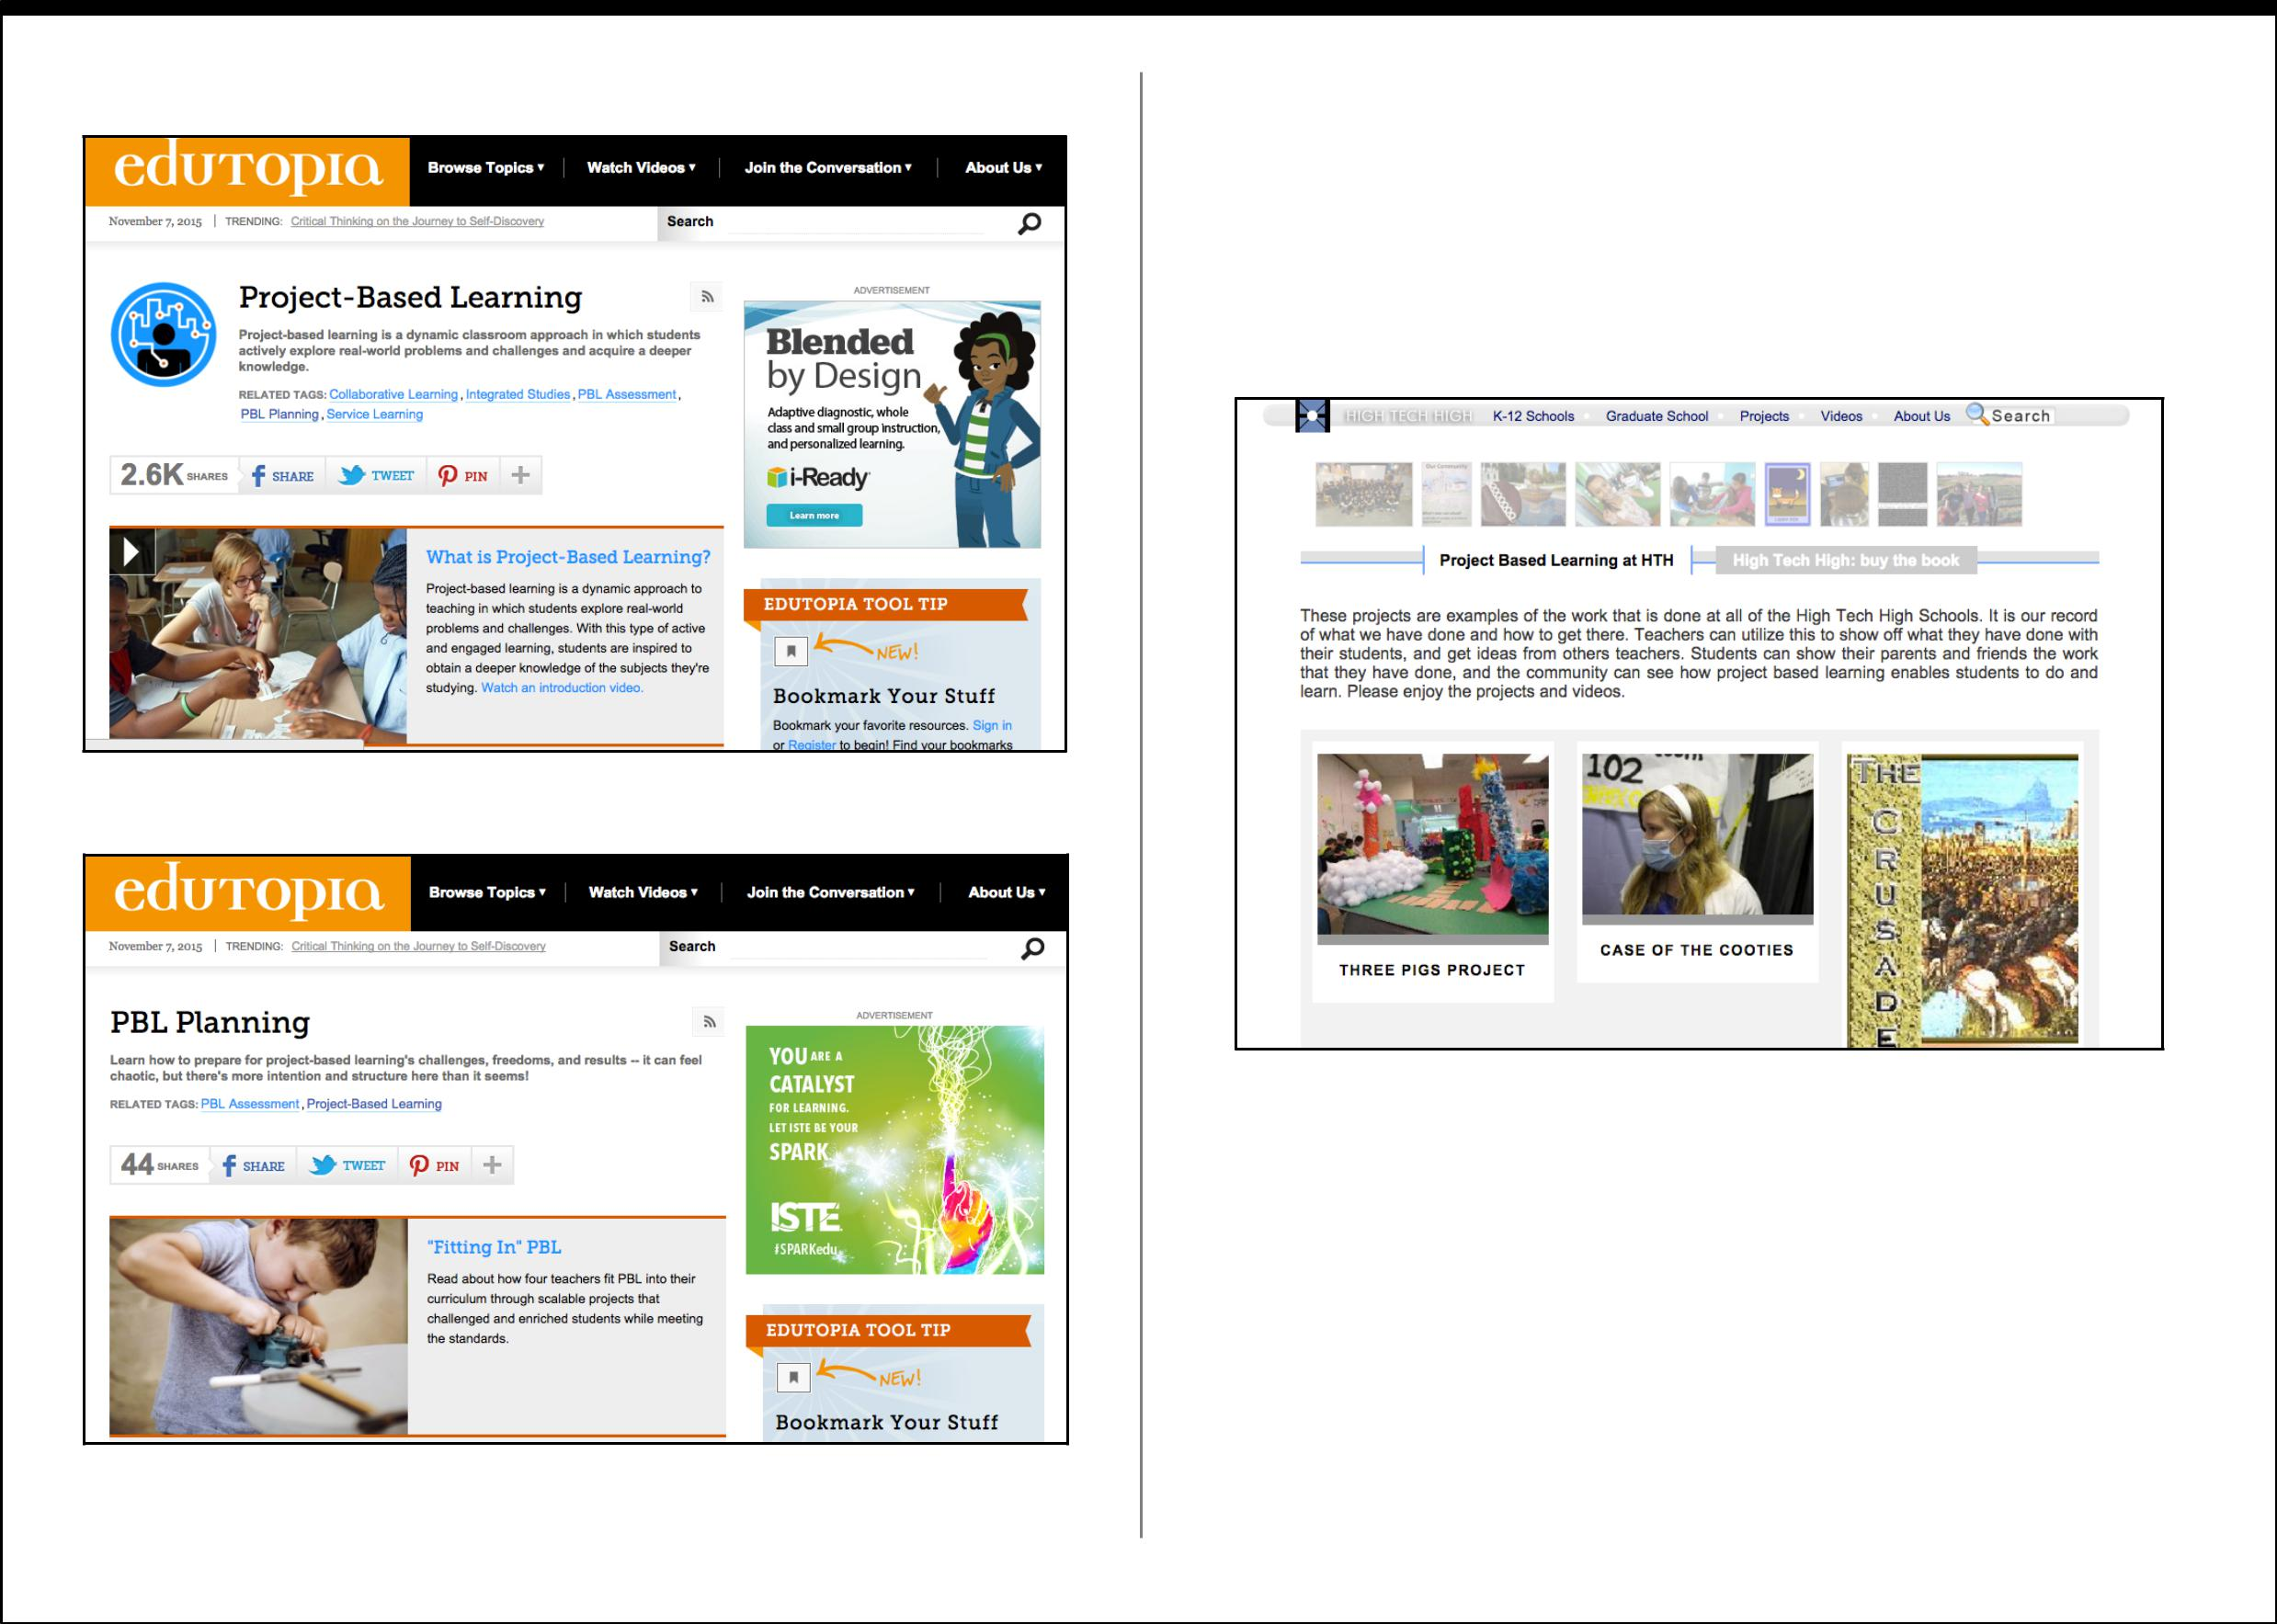
High Tech High Projects Page

This site is an incredible resource for any teacher looking to establish a Project Based Learning environment in their class. The page feature examples, overviews, videos, instruction and downloadable copies of learning materials for free. There is a wide range of subject areas, many cross-curricular, and tons of diﬀerent projects related to diﬀerent topics to choose from.

High Tech High is comprised of 13 charter schools in California. HTH’s focus is on developing academic, and citizenship skills, that will enable each student to be successful throughout their careers.

13

Final Thoughts

When I set out to research and write this publication, my intention was to create something that could help improve the classroom experience for students. As a proponent of collaborative, hands-on learning, and I knew I wanted to include PBL approaches, but didn’t know what my research angle would be.

As I began wading through dozens of scholarly articles, educational publications, and blog posts, it was eventually an online news article that popped up on my twitter feed, that led me to refining my eBook’s focus. My inspiration was a 2014 Newsweek article called, “What Classrooms Can Learn From the Google Campus” by Elijah Wolfson. Afer reading the article, about a new state-of-the-art school built in Connecticut, I found myself asking, “Can’t we do more with our current schools, without needing to spend 126-million dollars?” I knew our province wouldn’t spend that kind of money for just one school, so I began pondering how we could rethink and redesign our existing schools and classes to better serve BC students. This publication is a product of trying to answer “How we can do more with less?”

This eBook isn’t intended to provide all the answers. Its purpose is to oﬀer practical information, resources, and sound pedagogical advice, in hopes of inspiring others to rethink their classroom design and teaching approaches.

On the final page you will find more resources to help you make your school a place where students can be inspired to critically assess, create, innovate, and develop their 21st century skills.

Best of luck!

Jacob S. Main
Additional Resources:

8 Tips and Tricks to Redesign Your Classroom. Edutopia. http://www.edutopia.org/blog/8-tips-and-tricks-redesign-your-clas sroom

Aligning 21st Century Learning with 21st Century Learners. 21

Foundation https://www.youtube.com/watch?v=Zu01G8h4yNI

A new classroom design challenge. H. T. Roman. The Technology Teacher. March 2009, Vol. 68, No. 6. * Note: Weblink is a preview only. The full article available through Academic Databases.* https://www.questia.com/library/journal/1G1-195679868/a-new-cla ssroom-design-challenge-students-will-gain

Capture the Learning: Crafing the Maker Mindset. Edutopia. http://www.edutopia.org/blog/capture-learning-crafing-maker-mi ndset-lisa-yokana

Enabling Innovation. Transforming Curriculum & Assessment.

B r i t i s h C o l u m b i a , M i n i s t r y o f E d u c a t i o n. https://www.bced.gov.bc.ca/irp/docs/ca_transformation.pdf

New BC Curriculum. British Columbia Ministry of Education. https://curriculum.gov.bc.ca/home

Project Based Learning: Explained. Buck Institute for Education. https://www.youtube.com/watch?v=LMCZvGesRz8

Project Based Learning at High Tech High. Buck Institute for Education. https://www.youtube.com/watch?v=xfP53Alnbhk

Sir Ken Robinson: Bring on the Learning Revolution! TED Talks https://www.youtube.com/watch?v=r9LelXa3U_I

14

