Keepvid and Using Videos Offline in the class.
October 24th, 2014

Introduction:
As part of our District Professional Development Session on October 24th, I led as session on using video as part of an effective classroom strategy. The presentation revolved around the Dual-Coding Theory and the use of the website Keepvid.com for downloading and creating MP4 copies of YouTube videos.
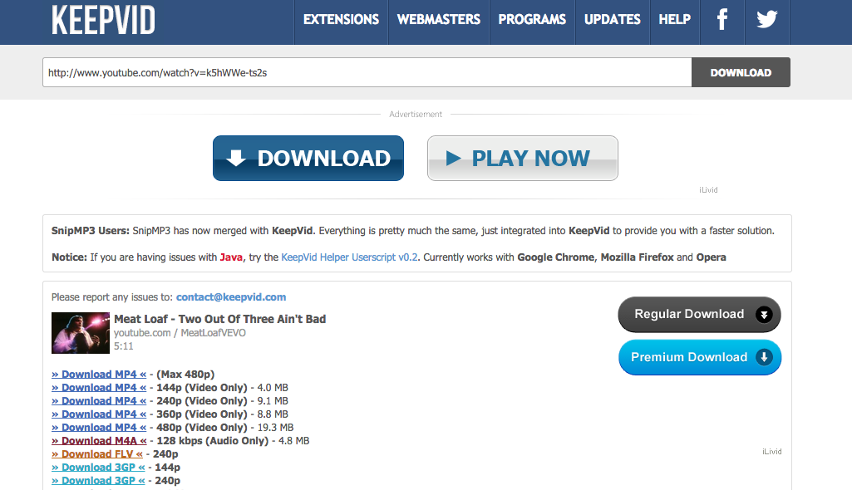
Reflection:
During the course of my presentation I gave a quick explanation of how the Dual-Coding Theory worked (I had only 7 minutes to present.) I gave them the Coles Notes version of the theory, explaining how our brain takes in information in through auditory and visual channels, and that by inundating students with too many wordy power points or text heavy videos, that the students will reach their saturation point, much faster than they would if they presented a video and took time during the video to stop, check for understanding or elaborate on a point within the video. I pointed also to the research from respected Multimedia expert Richard Mayer, who suggested in his study entitled “Nine Ways to Reduce Cognitive Load in Multimedia Learning” that the most effective method of instruction is “when presentation of corresponding visual and auditory material is simultaneous, there is no need to hold one representation in working memory until the other is presented. This situation minimizes cognitive load.” A quality video with proper preparation can both help engage the learners and lessen the cognitive load.

As a teacher in a school with weak Wi-Fi and poor bandwidth, I introduced my colleagues to the website Keepvid.com. The site converts YouTube videos for users, so that they can download and save MP4 copies of the videos. I was introduced to this free service by a co-worker while I was still teaching in South Korea, and I have used it ever since, to keep digital copies of educationally sound and relevant videos. The free service provided by Keepvid, has saved me from the spinning wheel of death and the need to wait for a strong enough Wi-Fi signal in order to stream online videos. Having MP4 versions saved to my hard drive has permitted greater opportunities to share the content with my students, by imbedding the videos into my class website and by sharing the material electronically with my colleagues.

While the principles of the Dual-Coding Theory may have gone over about as well as a Baron of Beef Buffet at a Vegetarian Convention, fortunately my co-workers were appreciative to learn about Keepvid.com, and the advice about how to better incorporate into their classes and class websites. In the immortal words of Meatloaf, “Two Out of Three Ain’t Bad.”

Links for further information:
Richard Mayer’s Study on Reducing Cognitive Load in Multimedia Learning:
http://cmapspublic2.ihmc.us/rid=1KXP7KR7M-8N27KG-1FNL/mayer_moreno_2003.pdf
Dual Coding Theory:
http://www.instructionaldesign.org/theories/dual-coding.html
http://en.wikipedia.org/wiki/Dual-coding_theory
Keepvid:
http://www.keepvid.com
http://www.imelfin.com/is-keepvid-safe-4-things-you-should-know-about-keepvid.html#.VIxcimTF_78
Meatloaf – Two out of Three Ain’t Bad:
https://www.youtube.com/watch?v=k5hWWe-ts2s

