Weebly Tutorial After School Tech Session.
November 13, 2014

As part of my continuing effort to improve the accessibility of my class to my students and their parents, I have been using the Weebly platform for my classroom blogsite. I had previously used Wordpress in my class and for my Masters studies, but I find the user interface, functionality and appearance much better. Like the Hatfields and the McCoys, we are a teaching staff divided in our allegiances between the blogsites. So in an effort of sway the undecided members of our staff, I held an after school session to highlight the varied uses of Weebly as an effective classroom delivery and management tool.
Our first task was to assuage the worries of some of the non-tech inclined staff that having a class website was a good investment of their time, and that by using Weebly, could help increase students accountability and decrease excuses. Weebly’s drag and drop page creation allows inexperienced users the ability
to customize their layout and easily create great looking pages. We walked the teachers through both the layout page and how to add material to an existing page.
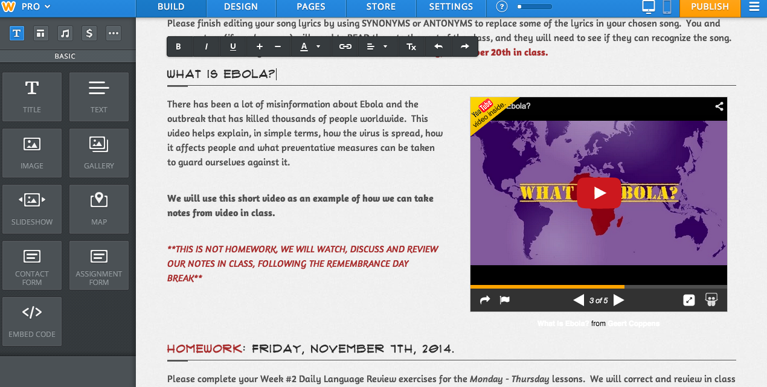
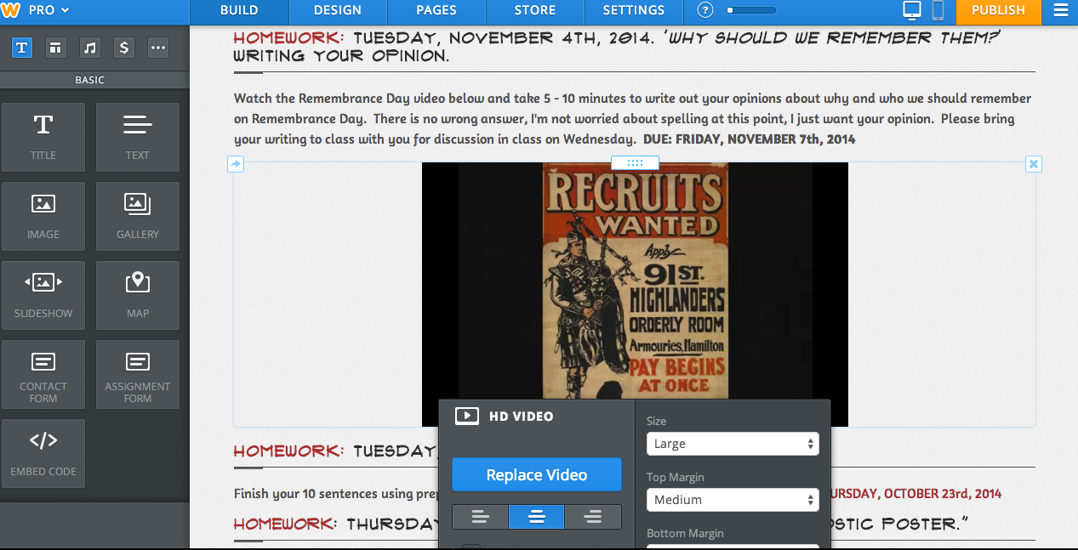
One of the biggest revelations for the staff in attendance was how easy it was to embed documents and videos into the page. By using video converter programs like Keepvid or through YouTube, adding video content to the page for pre-learning purposes or for review is simple. Another great feature of Weebly is that you can format the size an position of the video on your page, so that if you want to relay information, key points or questions about the video, the text can be strategically placed next to the video.
In terms of other possibilities brought up during the tech session, some of the teachers in attendance discussed the ability to upload additional worksheets, documents, images or videos as extensions for students who want to dig a little deeper into a subject matter or simply need to do additional work to achieve grade level performance.

One final tip that I was able to share about using Weebly as a class website was how easily we can keep both parents and students up to date on what is happening in the class. I added a tab called the “Daily Rundown” which permits parents and absent students alike, an opportunity to see what took place in class on any particular day. One of the unintended benefits has been that it is easy for me to got back and find exact dates as to when we discussed or learned about specific topic. The Daily Run Down and helped me create an online chronicle of class successes and challenges.
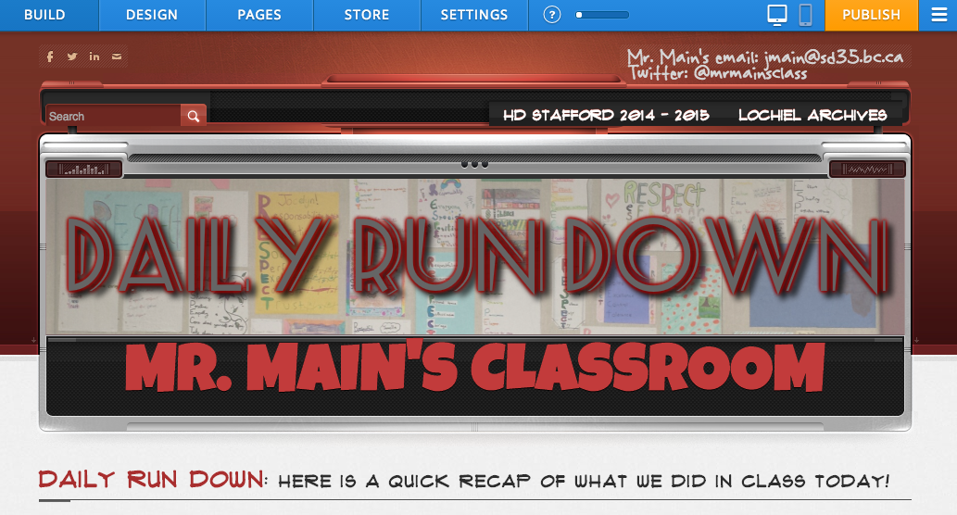
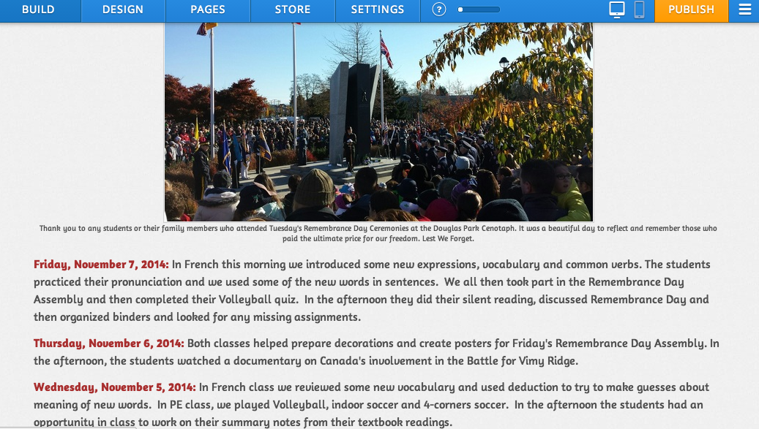
One final point that I had hoped to bring up, but ran out of time, was Weebly’s ability to post comments and facilitate online debate and discussion. I used this tool in the past for homework assignments, to generate online discussion and to drive more students to the website as virtual classroom and not just a homework posting board.

All in all, the session went well. Poor Wi-Fi really hampered the ability to get all of the different teachers up and running as quickly as I had hoped, so rather than being the workshop format I had envisioned, it became more about sharing information and offering possibilities for each of the teacher to customize their classroom site. The best news that came from the session has been the number of the teachers who have told me how much they enjoy using the site, and how it has helped increase accountability with their students, and decreased the amount of questions about homework and missing assignments.

